Colusa County Water District Water Management Plan 2020 Criteria

Date of first draft – October 2021 Date of final – April 13, 2022

Index

Page
Section 1: Description of the District 3
Section 2: Inventory of Water Resources 11
Section 3: Best Management Practices (BMPs) for Agricultural Contractors 16
Section 4: Best Management Practices for Urban Contractors N/A
Section 5: District Water Inventory Tables 24

Attachment A District Maps (GIS electronic file)...............................................................................
Attachment B District Rules and Regulations .....................................................................................
Attachment C Measurement Device Documentation ..........................................................................
Attachment D District Sample Bills ....................................................................................................
Attachment E District Water Shortage Plan (Drought Ordinance 2009-1) ......................................... Attachment F Groundwater Management Plan...................................................................................
Attachment G Groundwater Banking Plan ..........................................................................................
Attachment H Annual Potable Water Quality Report – Urban .......................................................... Attachment I Notices of District Education Programs and Services Available to Customers........... Attachment J District Agricultural Water Order form........................................................................
Attachment K Drainage Problem Area Report ....................................................................................
Attachment L Other (define) ...............................................................................................................
Attachment M Other (define) ...............................................................................................................

Section 1: Description of the District
District Name: Colusa County Water District Contact Name: Shelly Murphy Title: General Manager Telephone: 530 476-2669
E-mail: ccwd2@frontiernet.net Web Address none

- History
  - Date district formed: May 18, 1954 Date of first Reclamation contract: May 14, 1962
Original size (acres): 27,196 / 23,841 Current year (last complete calendar year):2019

  - Current size, population, and irrigated acres
Data Year | 2019
Size (acres) | 45,670
Population served | NA
Irrigated acres | 34,693
*irrigated acres are those acres receiving water from CCWD. Assessed acres include acres that could be irrigated with CCWD water but are either idle or use private groundwater. Irrigated acres above reflect M&I acres taking water for irrigated landscape - Golf Course and Cemetery. This is not reflected in A6 table as it states agricultural only.

  - Water supplies received in 2019
Water Source | AF
Federal urban water (Tbl 1) | 109
Federal agricultural water (Tbl 1) | 20,306
State water (Tbl 1)
Other Wholesaler (define) (Tbl 1)
Local surface water (Tbl 1)
Upslope drain water (Tbl 1)
District ground water (Tbl 2)
Banked water (Tbl 1)
Transferred water (Tbl 6) | 20,000
Recycled water (Tbl 3)
Other (define) (Tbl 1) –215 water Ag | 9950
Other (define) (Tbl 1) –215 water MI | 50
Total | 50,415

  - Annual entitlement under each right and/or contract
 | AF | Source | Contract # | Availability period(s)
Reclamation Urban AF/Y | 300+/- | USBR | 14-06-200-304-A-LTR1 | Yearly Mar 1- Feb 28 Subject to M&I shortage policy

Reclamation Agriculture AF/Y | 62,200 | USBR | 14-06-200-304-A-LTR1 | Yearly Mar 1 - Feb 28 Subject to BOR  Allocation Announcement
Reclamation Agriculture AF/Y | 5,666 | USBR | 1-07-20-W0220-LTR1  County of Colusa Sub-Contract Assignment | Yearly Mar 1 - Feb 28 Subject to BOR  Allocation Announcement
Other AF/Y | (25,000)  12,000 | Westside WD (USBR) | Transfer agreement –  12,000 AF up to 25,000 | See Above
Other AF/Y | 8,000 | RD108  (USBR) | 5 year “In-Lieu”  Transfer Agreement | June – October  (2018-2022)

  - Anticipated land-use changes

Due to increasing land-based costs, District anticipates fallowed/unplanted acres will transition to irrigated crops as well as shift from annual crops to more permanent crops.
  - Cropping patterns (Agricultural only)

List of current crops (crops with 5% or less of total acreageare combined in the ‘Other’ category).
Original Plan (1992) |  | Previous Plan (2013) |  | Current Plan (2019)
Crop Name | Acres | Crop Name | Acres | Crop Name | Acres
Almonds | 14,943 | Almonds | 26,442 | Almonds | 28,918
Vineseed | 1,395 | Wheat | 1,183 | Alfalfa | 580
Wheat | 1,663 | Grapes | 1,415 | Grapes | 1,315
Grapes | 1,021 | Tomatoes | 1,091 | Tomatoes | 402
Alfalfa | 1,143 | Vineseeds | 1,223 | Vineseeds | 827
 |  |  |  | Wheat | 638
 |  |  |  | Walnuts | 643
Other (<5%) | 1,910 | Other (<5%) | 3,007 | Other (<5%) | 1,277
Total | 22,075 | Total | 34,361 | Total | 34,600

  - Major irrigation methods (by acreage) (Agricultural only)

Original Plan (1992) |  | Previous Plan (2008) |  | Current Plan (2019)
Irrigation Method | Acres | Irrigation Method | Acres | Irrigation Method | Acres
Border | 1,745 | Border |  | Border | 1333
Sprinkle | 11,867 | Sprinkle | 2,556 | Sprinkle | 249
Furrow | 5,410 | Furrow | 1,377 | Furrow | 373
Drip | 3,053 | Drip | 30,428 | Drip | 32,645
TOTAL | 22,075 | TOTAL | 34,361 | TOTAL | 34,600

- Location and Facilities
A general boundary map of the Colusa County Water District and its sphere of influence is in Attachment A. Electronic maps containing the following: conveyance system (TC canal), incoming flow locations (canal side pumping plants), re-lift pump stations with regulating reservoirs and/or tanks, distribution system (pipelines) and turnouts (meters) are available upon request. Due to cyber-security concerns these items are not available to the general public. No outflow/spill locations are identified and the District does not own or operate any wells or have water quality monitoring locations and/or groundwater facilities.

Water is diverted from the T-C Canal at eight locations. Five of the diversions are by pump and three are by gravity. Water from each diversion enters a closed pipeline distribution system.
The eight separate pipeline lateral systems which comprise the irrigation distribution system of the District are numbered from north to south: 6BP, 5BP, 4G, 3BP, 2BP, 2BG, 7AP, 8G. Pumped systems are designated by the letter P. and the gravity systems designated by the letter
G. The pumped systems are served by canal side pumping plants and water is delivered into the gravity systems through gates on the canal side turnouts. System 6A, 6B, 3B, 3BA share a common turnout structure and flow meters, although the systems are operated independently. All systems include buried pipelines, farm outlets (also referred to as farm turnouts), and appurtenant facilities. Gravity flow systems serve lands located to the east of the Tehama-Colusa Canal while the pumped systems predominantly serve lands on the western side of the canal. See Map (ii) for District diversion facilities.

- Incoming flow locations and measurement methods
Location Name | Physical Location | Type of Measurement Device | Accuracy
6BP-1&2 | R.3 W.14 (SW corner) | - Venturi Meter/  - Sontek | < 5%  < 2%
5BP | R.2 W.19 (SE corner) | Venturi Meter | < 5%
Turnout 4 (4G) | R.2 W 20 (center) | McCrometer | < 5%
3BP-1&2 | R.2 W.33 (SW corner) | Venturi Meter | < 5%
2BP-1&2 | T.13N.R 2W 14 (SE corner) | 1-McCrometer/ 2-Sontek | < 5%  < 2%
2BG | T.13N.R 2W 14 (SE corner) | Venturi Meter | < 5%
7AP | T.13N.R 2W 25 | Venturi Meter | < 5%
Turnout 8G-1&2 | T.13N.R1W 31 | 1-McCrometer/ 2-Sontek | < 5%  < 2%

The above metering devices are operated and maintained by the Tehama Colusa Canal Authority (TC) for the Bureau. The Venturi sizes range 30”– 54”. Unfortunately, the TC found that the Sontek meters were unreliable and required replacement more often and are now transitioning back to the Venturi style meters.

- Current year Agricultural Conveyance System
Miles Unlined - Canal | Miles Lined - Canal | Miles Piped | Miles - Other
0 | 0 | 105 | 0

3 Current year Urban Distribution System
- Storage facilities (tanks, reservoirs, regulating reservoirs)
Name | Type | Capacity (AF) | Distribution or Spill
6A | Regulating Tank | 1.11 | Distribution
6B | Regulating Tank | 1.48 | Distribution
5B | Regulating Tank | .92 | Distribution
3A | Regulating Tank | .92 | Distribution
3CD | Regulating reservoir |  | Distribution
3CG | Regulating reservoir |  | Distribution
3D | Regulating reservoir |  | Distribution
3D | Regulating Tank | .59 | Distribution
3G | Regulating Reservoir |  | Distribution
2C | Regulating reservoir |  | Distribution
2D | Regulating reservoir |  | Distribution
2E | Regulating Reservoir |  | Distribution
7B | Regulating reservoir |  | Distribution
7B | Regulating Tank | .77 | Distribution

- Description of the agricultural spill recovery system and outflow points.

NONE– no spill, completely piped system
Provide this information in Section 2 F.

- Agricultural delivery system operation (check all that apply)
On-demand | Scheduled | Rotation | Other (describe)
 | X | X
The District delivery system is scheduled (11am prior day notice for turn on and turnoff), with 1/3 limitation which results in some rotation type restrictions.

- Restrictions on water source(s)
Source | Restriction | Cause of Restriction | Effect on Operations
CVP Water Service Contract | Reduced Allocations | Drought, Regulatory restraints | Water rationing and/or increased groundwater pumping &  transferred water purchases
Transfer water | Reduced  Allocations, Contract limitation | See above Cost of water | Increased groundwater pumping,  water rationing, crop idling, loss of trees/permanent crops
All source – CVP & Transfer water | Rotational delivery times | District system designed as a “3-day system” | Transition to drip irrigation, water users unable to irrigate everyday – rotation often means  they convert to GW pumping

- Proposed changes or additions to facilities and operations for the next 5 years –

Currently, there are no plans for changes/additions to existing facilities. The District has had landowner requests to upgrade system in order to eliminated “3-day” system of rotation and help reduce reliance on groundwater to meet irrigation needs however, in order to increase pipeline capacities, pumping plants would also need to be upgraded. Not only would this work be cost prohibitive, the Districts current water service contract quantities do not justify the upgrades.

Due to SGMA the District does anticipate operational changes within the District over the next 5 years. Currently, the gravity flow systems of the District are under-utilized due to less expensive groundwater pumping costs on the east side compared to the western side of District. As a founding member of the Colusa Groundwater Authority (CGA) the District has been working with the other CGA members on finalizing the Groundwater Sustainability Plan (GSP) for the Colusa Sub-basin. This plan is due by January 2022 and once implemented the District expects surface water use to increase as a result of potential costs or limitations on groundwater pumping.
The passage of the WINN Act in 2016 allowed the District to complete the contract conversion process in hopes that the reduction in water rates from paying off the construction component would further incentivize the use of surface supplies over groundwater pumping in years that the District received an ample CVP allocation. Unfortunately, the current drought has not allowed for this to come to fruition.

- Topography and Soils
  - Topography of the district and its impact on water operations and management
The District lies on recent and older alluvial fan soils of the eastern slopes of the Pacific Coast Range. The topography of the District varies slightly from gently rolling (slopes less than 6%) in the west to relatively flat (slopes of 10 ft per mile) in the easterly portion. The unleveled greater slopes are suitable for sprinkler or drip irrigation and constitute most of the District land devoted to orchard.

  - District soil association map (Agricultural only)
See Attachment B, District Soils Map

  - Agricultural limitations resulting from soil problems (Agricultural only)
Soil Problem | Estimated Acres | Effect on Water Operations and Management
Salinity | NA
High-water table | NA
High or low infiltration rates | NA
Other (define) | NA

- Climate
  - General climate of the district service area

The service area climate is typical of the Sacramento Valley and is generally characterized by two distinct seasons: a hot, dry summer and a cool, wet winter. Annual precipitation averages about 16 inches and occurs almost entirely between November and March. Between May and September rainfall averages about 1.5 inches with a range of 0 to 5.5 inches. Hot, dry north winds are common during the summer with the average daily temperature of 95 F for July. The winter is generally mild with an average of 256 frost free days per year and a range of 188 to 336 days.

However, over the past ten years, there has been a significant change in weather patterns, generally warmer, drier patterns offset by greater rainfall associated with flooding verses colder snow patterns.

 | Jan | Feb | Mar | Apr | May | Jun | Jul | Aug | Sep | Oct | Nov | Dec | Annual
AvgPrecip. | 3.25 | 2.70 | 1.95 | .98 | .35 | .22 | .03 | .07 | .37 | .75 | 2.14 | 2.80 | 15.61
Avg Temp. | 45.3 | 49.9 | 53.6 | 59.0 | 67.1 | 74.7 | 78.5 | 76.5 | 71.9 | 63.7 | 52.6 | 45.6 | 61.5
Max. Temp. | 54.5 | 60.8 | 65.8 | 73.2 | 82.1 | 91.2 | 96.6 | 94.6 | 89.1 | 79.2 | 64.6 | 55.4 | 75.6
Min. Temp | 36.1 | 39.0 | 41.3 | 44.8 | 52.0 | 58.3 | 60.4 | 58.4 | 54.8 | 48.3 | 40.6 | 36.5 | 47.6
ETo (32) | 1.21 | 2.58 | 3.65 | 5.42 | 7.00 | 8.01 | 7.72 | 6.33 | 5.24 | 4.81 | 2.05 | 1.58 | 4.63

CIMIS ID Williams, CA (049677) Data period: Year 1906 to Year 2016

Average wind velocity 5.4 mph Average annual frost-free days: 254

  - Impact of microclimates on water management within the service area
NONE

- Natural and Cultural Resources
  - Natural resource areas within the service area
Name | Estimated Acres | Description
NONE
  - Description of district management of these resources in the past or present
NA

  - Recreational and/or cultural resources areas within the service area
Name | Estimated Acres | Description
NONE

- Operating Rules and Regulations
  - Operating rules and regulations
See Attachment C, District Rules and Regulations (water related)

  - Water allocation policy (Agricultural only)
See Attachment C, Page 1, and Attachment E, Drought Ordinance 2009-1

Summary - The District's water allocation policy as stated in item 1 of Rules and Regulations and item 1 of the Drought Ordinance as follows: "Each property having full water rights and eligible under Reclamation Law and District rules to receive water in a year will be allocated a quantity of water based on its assessed acres...”

  - Official and actual lead times necessary for water orders and shut-off (Agricultural only)
See Attachment C, Page 2
Summary - The minimum lead time necessary for water orders is stated in item 8 of the Rules and Regulations as "before 1:00 pm the day before starting an irrigation." The minimum lead time necessary for water shut-off is stated in item 8 of the Rules and Regulations as "before l:00 pm the day prior to finishing an irrigation.

  - Policies regarding return flows (surface and subsurface drainage from farms) and outflow (Agricultural only)
See Attachment C, Page 2

Summary - The District's return flows policy is stated in item 10 of the Rules and Regulations as follows: "To avoid drainage problems, it shall be the responsibility of every water user to control the water to be applied to his land. Any water user who deliberately, carelessly, or otherwise wastes water on roads, adjoining land, or creeks will be informed by District personnel that he is not complying with this rule. He will be allowed a reasonable time to correct the situation. If he makes no prompt effort of correction, his water service will be discontinued."

  - Policies on water transfers by the district and its customers
See Attachment D,

Ordinance No. 2009-01 Establishing Rules and Regulation for Water Delivery during a Water Shortage Emergency
- Water Measurement, Pricing, and Billing

- Agricultural Customers

Refer to BMP A.1. Information on water measurement for agricultural contractors is completed under BMP A.1 on page 4-15.

- Urban Customers

  - Total number of connections 10
  - Total number of metered connections 10
  - Total number of connections not billed by quantity 0
  - Percentage of water that was measured at delivery point 90%
  - Percentage of delivered water that was billed by quantity 100%
While all deliveries have metering devices installed sometimes meters fail when this happens water use is either calculated using orders or estimated based on crop needs.

f. Measurement device table

Meter Size and Type | Number | Accuracy (+/-  percentage) | Reading Frequency (Days) | Calibration Frequency (Months) | Maintenance Frequency (Months)
2"
3" Seametrics | 3 | +/- 1% | 30 | 60 | Every 60 mos or as needed
4" Propeller | 4 | +/- 2% | 30 | 60 | Every 60 mos. or earlier if necessary
6" Propeller | 1 | +/- 2% | 30 | 60 | “ “
8" Propeller | 2 | +/- 5% | 30 | 60 | “ “
Other (define)
Total | 10

- Agriculture and Urban Customers

The District “Urban Customers” are non-potable irrigation use delivered under an M&I contract.

  - Current year agriculture and /or urban water charges - including rate structures and billing frequency

The Districts agricultural water charge is set annually with the rate applied by quantity and structured as a uniform rate per acre-foot of metered use to encourage water conservation. Water user billings are described in item 5 of the Rules and Regulations as follows: "Prior to April 15, the District must receive one-half of each user’s seasonal estimate. Prior to July 1, the balance of each estimate is due. Any balance due or credit is determined by final meter readings. No water will be delivered until installments are paid." Meter readings are done monthly with final meter reading in November/December weather permitting.

  - Annual charges collected from customers (current year data)
Fixed Charges (Urban & Ag)
Charges ($ unit) | Charge units | Units billed during year  (acres) | $ collected ($ times units)
$9.25 | $/assessed acre | 39,872 | $368,816
$24.50 | Per assessed acre | 39,872 | $976,864
Volumetric charges
Charges ($ unit) | Charge units | Units billed during year  AF | $ collected ($ times units)
$106.00 | $/AF (Ag) | 50,038 | $5,304,028
$167.31 | $/AF (full cost) | 218 | $36,474
$74.00 | $/AF (urban) | 159 | $11,766
 | TOTAL | 50,415 | $5,352,268
See Attachment E, District Sample Bills

  - Describe the contractor’s record management system
See Attachment E, District Sample Bills

In 2017, the District purchase Sage100 billing software to integrate with the H20 meter reading program. This eliminated the outdated Dbase program it had been using allowing for more reliable integration of readings and subsequent water charges. All records have automated backup and District retention policies dictate how long these records are available.

H. Water Shortage Allocation Policies
- Current year water shortage policies or shortage response plan - specifying how reduced water supplies are allocated
See Attachment D, Drought Ordinance 2009-1

The District's water allocation policy as stated in item 1 of the Drought Emergency Plan as follows: "Each property having full water rights and eligible under Reclamation Law and District rules to receive water in a year will be allocated a quantity of water based on its assessed acres. The number of acre-feet is to be determined by dividing the total water available to the District by the total assessed acreage in the District.

- Current year policies that address wasteful use of water and enforcement methods
See Attachment C and Attachment D; item 3 and item 5

The District's policy that address wasteful use of water and enforcement is stated in item 10 of the Rules and Regulations as follows: "To avoid drainage problems, it shall be the responsibility of every water user to control the water to be applied to his land. Any water user who deliberately, carelessly, or otherwise wastes water on roads, adjoining land, or creeks will be informed by District personnel that he is not complying with this rule. He will be allowed a reasonable time to correct the situation. If he makes no prompt effort of correction, his water service will be discontinued."

I. Evaluate Policies of Regulatory Agencies Affecting the Contractor and Identify Policies that Inhibit Good Water Management.
Good water management starts with an abundant, secure water supply which is lacking in California. Environmental interests have forced regulators to implement policies that inhibit irrigated lands groundwater recharge hurting the water cycle as a whole. Areas with ephemeral streams could be “stair-stepped” or staggered to slow down the runoff of water that only occurs during high rain events and be allowed to percolate into the aquifers, recharging much of California’s underground supply. Current streambed alteration policies prevent this even when the so-called stream is dry 90% of the time. The “conservation” mantra has not only prevented more storage projects from being built but has forced agricultural users to install drip irrigation systems that also do not allow for any extra seepage into the groundwater basin.

Section II: Inventory of Water Resources
- Surface Water Supply
  - Surface water supplies in acre feet, imported and originating within the service area, by month.
See Water Inventory Tables, Table 1

  - Amount of water delivered to the district by each of the district sources for the last 10 years
See Water Inventory Tables, Table 8

- Ground Water Supply
  - Groundwater extracted by the district and delivered, by month (Table 2)

Water Inventory Tables, Table 2 – No groundwater is extracted by the District. Landowners may pump groundwater and convey it through the system for their own use utilizing the Bureau Warren Act Contract. This water is metered and accounted for per Contract requirements.

    - Ground water basin(s) that underlies the service area
Name | Size (Square Miles) | Usable Capacity (AF) | Safe Yield* (AF/Y)
Sacramento Valley | 5,000 | 22,000,000 | 28,000 (CCWD)
*the safe yield in CCWD service area according to Colusa County Groundwater Management Plan

    - Map of district-operated wells and managed ground water recharge areas

CCWD does not own or operate any groundwater wells nor does it currently have any formally identified groundwater recharge areas. Due to conservation requirements and limited surface water supplies most of the District has converted to drip or micro-sprinkler irrigation. This conversion from furrow/flood/sprinkler pipe irrigation limits groundwater recharge capabilities.

However, in 2018, the District entered into an “in-lieu” groundwater recharge project with RD108. The hope was to bring more surface water into the District in order to help recharge groundwater supplies by conserving them and using more surface water. However, due to allocation reductions in CCWD’s CVP supply and the cost of pumping groundwater being significantly less than the surface supply the benefits of the project have not yet been fully actualized.

In addition to the “in-lieu” project the CGA and member agencies are working with landowners within the District on a “pilot-project” for groundwater recharge however the water source for this recharge has yet to be identified.

    - Description of conjunctive use of surface and ground water

The District has roughly 40,000 acreas of irrigable land and two surface water contracts for a total of 67,866 acre-feet (AF) of water. This equates to about 1.7 AF per acre of water. Most crops require between two and three AF per acre. Therefore, CCWD has been conjunctively using surface water and groundwater for years.

- Ground Water Management Plan

Although, the Colusa County Board of Supervisors adopted a county-wide groundwater management plan in 2008 (see http://colusagroundwater.ucdavis.edu/ for a complete copy of the plan) since then SGMA forced the formation of groundwater sustainability agencies (GSA’s) in California. CCWD is a member of the Colusa Groundwater Authority (CGA) and is in the process of developing its Groundwater Sustainability Plan (GSP) for submittal by the January 2022 deadline. Information regarding this plan can be found at http://colusagroundwater.org.
- Ground Water Banking Plan
NONE

- Other Water Supplies
  - “Other” water used as part of the water supply – Describe supply
See Water Inventory Tables, Table 1

“Other” water used is water made available to the District through transfer agreements with neighboring districts. The District water service contract is not sufficient for the total acreage within the boundaries and as such multi-year arrangements not only help in good years but are a necessity in reduced allocation years.

- Source Water Quality Monitoring Practices
  - Potable Water Quality (Urban only)

All M&I deliveries are non-potable no water quality monitoring is necessary.

  - Agricultural water quality concerns: Yes No X (If yes, describe)

  - Description of the agricultural water quality testing program and the role of each participant, including the district, in the program

All water delivered is from surface supplies delivered by the Tehama Colusa Canal Authority under BOR contract. At present there are no water quality issues however, information can be obtained from the TCCA Water Quality Sampling Program.

  - Current water quality monitoring programs for surface water by source (Agricultural only)

TCCA conveys surface water. Information can be obtained directly from TCCA’s Water Quality Sampling Program.

  - Current water quality monitoring programs for groundwater by source (Agricultural only)

CCWD does not own or operate any groundwater wells. Individual customers that utilize the Warren Act Contract with BOR are required to test the groundwater bi-yearly and

meet the standards stipulated in the BOR Warren Act Contract. Wells that do not meet the standard criteria are not permitted to pump into the Tehama Colusa Canal.

- Water Uses within the District
  - Agricultural
See Water Inventory Tables, Table 5 - Crop Water Needs

  - Types of irrigation systems used for each crop in current year

Crop name | Total Acres | Level Basin -  acres | Furrow - acres | Sprinkler - acres | Low Volume -  acres | Multiple methods -  acres
Alfalfa | 580 | 580
Almonds | 28918 |  |  | 30 | 28,888
Apples | 3 |  |  |  | 3
Apricots | 6 |  |  |  | 6
Beans | 167 |  | 167
Pears | 15 |  |  |  | 15
Asparagus | 21 |  |  |  | 21
Figs | 5 |  |  |  | 5
Grapes | 1316 |  |  |  | 1316
Other Fruit | 10 |  |  |  | 10
Other Hay | 55 |  |  | 55
Other Veg | 42 |  |  |  | 42
Olives | 406 |  |  |  | 406
Onions | 28 |  | 28
Pasture | 194 | 30 |  | 164
Peaches | 6 |  |  |  | 6
Pistachios | 131 |  |  |  | 131
Prunes | 102 |  |  |  | 102
Rice | 85 | 85
Tomatoes | 402 |  |  |  | 402
Vineseed | 827 |  | 178 |  | 649
Walnuts | 643 |  |  |  | 643
Wheat | 638 | 638
TOTAL | 34600 | 1333 | 373 | 249 | 32645

  - Urban use by customer type in current year

Customer Type | Number of Connections | AF
Landscape irrigation | 6 | 151
Other (livestock) | 2 | 2
Fire Protection | 2 | 6
Unaccounted for |  | 0
Total |  | 159

Treatment Plant | Treatment Level (1, 2, 3) | AF | Disposal to / uses
NONE

5.Ground water recharge/management in current year (Table 6)

Recharge Area | Method of Recharge | AF | Method of Retrieval
NONE

6a. Transfers and exchanges into the service area in current year – (Table 1)
From Whom | To Whom | AF | Use
Westside WD | CCWD | 12,000 | Ag/Crop Irrigation
RD108 | CCWD | 8,000 | Ag/Crop Irrigation
 | Total | 20,000

6b. Transfers and exchanges out of the service area in current year – (Table 6)
From Whom | To Whom | AF | Use
NONE
 | Total

7. Wheeling, or other transactions in and out of the district boundaries – (Table 6)
From Whom | To Whom | AF | Use
NONE
8. Other uses of water in current year
Other Uses | AF
NONE

- Outflow from the District (Agricultural only)
  - Surface and subsurface drain/outflow in current year
NONE - District does not have drain or outflow issues with surface supply. 90% Drip or micro-sprinkler irrigation with little to no run off.

  - Description of the Outflow (surface and subsurface) water quality testing program and the role of each participant in the program
NONE – District does not have need for program however, landowners within the District belong to the Colusa Basin Sub Watershed to cover any water that may “run-off” due to irrigation problems or high rain events.

  - Outflow (surface drainage & spill) Quality Testing Program
NONE - District is within Colusa Sub-basin Drainage District boundaries. They provide all necessary testing and information.

  - Provide a brief discussion of the District’s involvement in Central Valley Regional Water Quality Control Board programs or requirements for remediating or monitoring any contaminants that would significantly degrade water quality in the receiving surface waters.

CCWD and its customers have no surface or subsurface outflow. CCWD customers are members of the Colusa Basin Watershed group which does conduct required runoff water quality testing.

- Water Accounting (Inventory)
  - Water Supplies Quantified
- Surface water supplies, imported and originating within the service area, by month (Table 1)
- Ground water extracted by the district, by month (Table 2)
- Effective precipitation by crop (Table 5)
- Estimated annual ground water extracted by non-district parties (Table 2)
e. Recycled urban wastewater, by month (Table 3)
f. Other supplies, by month (Table 1)

  - Water Used Quantified
- Agriculturalconveyance losses, including seepage, evaporation, and operational spills in canal systems (Table 4) or Urban leaks, breaks and flushing/fire uses in piped systems (Table 4)
- Consumptive use by riparian vegetation or environmental use (Table 6)
- Applied irrigation water - crop ET, water used for leaching/cultural practices (e.g., frost protection, soil reclamation, etc.) (Table 5)
- Urban water use (Table 6)
e. Ground water recharge (Table 6)
- Water exchanges and transfers and out-of-district banking (Table 6)
- Estimated deep percolation within the service area (Table 6)
- Flows to perched water table or saline sink (Table 7)
i. Outflow water leaving the district (Table 6)
j. Other

  - Overall Water Inventory
a. Table 6

Section III: Best Management Practices (BMPs) for Agricultural Contractors
- Critical Agricultural BMPs
  - Measure the volume of water delivered by the district to each turnout with devices that are operated and maintained to a reasonable degree of accuracy, under most conditions, to +/- 6%

- Number of delivery points (turnouts and connections) 703
- Number of delivery points serving more than one farm 10
c. Number of measured delivery points (meters and measurement devices) | 703
d. Percentage of delivered water that was measured at a delivery point | 95%
- Total number of delivery points not billed by quantity 0
- Delivery point measurement device table

Measurement Type | Number | Accuracy* (+/- %) | Reading Frequency (Days) | Calibration Frequency (Months) | Maintenance Frequency (Months)
Orifices
Propeller meter* | 703 | +/- 6% | 30 | 60 | Every 1000 AF or sooner if necessary
Weirs
Flumes
Venturi
Metered gates
Acoustic Doppler
Other (define)
Total | 703
*All District meters are instantaneous flow rate indicating, totalizing, in pipe throughout the District and the accuracy stated is only for operation within designed and specified flow range. See attached meter accuracy documentation – Attachment F.

  - Designate a water conservation coordinator to develop and implement the Plan and develop progress reports

Name: Shelly Murphy Title: General Manager Address:840 1st Street, Arbuckle CA 95912 Telephone:(530) 476-2784 E-mail: ccwd2@frontiernet.net
The District General Manager acts as the water conservation coordinator. She/he is responsible for updating and implementing the plan as well as developing progress reports.

Job Description: Manages and coordinates water conservation activities including studies, programs and audits. Designs, implements, administers and promotes various water use efficiency programs as time and resources allow. Monitors and evaluates program results and impacts on conservation efforts.

Minimum Qualifications: Any combination of experience and training that would likely provide the required knowledge and abilities. Including but not limited to 3 years of increasing responsibility providing water management and conservation, including one year of program coordination activities.

  - Provide or support the availability of water management services to water users

See Attachment I, Notices of District Education Programs and Services Available to Customers.

  - On-Farm Evaluations

    - On farm irrigation and drainage system evaluations using a mobile lab type assessment
 | Total in  district | # surveyed last year | # surveyed in current  year | # projected for next year | # projected 2ndyr in future
Irrigated acres | 34,600
Number of farms | 260 | 0 | 0 | 0 | 0
*total acres are what’s irrigated with District water; total irrigable acres is greater
Landowners within the District are notified via e-mail, mailers and presentations of services available from PG&E, Chico State and Colusa County RCD to assess their irrigation practices and efficiency. E-mails are sent as soon as the District receives notice from one of these entities offering services. This is generally 2 to 3 times a year. To date, the District is unaware of any landowners who have utilized these services. However, several landowners have purchased computerized probe technology that has helped them determine irrigation needs and efficiency on their own farms. Furthermore, the District does perform “on-farm” evaluations via random checks by O&M staff on landowners throughout the District while traveling their daily routes. These evaluations address water usage relative to zero tail-water (waste) and making growers aware of problems that may exist.

    - Timely field and crop-specific water delivery information to the water user

The District collects and compiles water use by crop and field, which it has distributed widely since 1995. Monthly meter readings are available totalizing use and the District provides an annual review of water use in acre feet per acre for the entire District so that each water user can compare his annual use to the District wide summary to see if any improvements to his irrigation practices are needed. This information is available at District office upon request.

  - Real-time and normal irrigation scheduling and crop ET information
The District and its customers make use of the Soil Conservation Service, UC Davis Agricultural Extension Offices, the office of the Agricultural Commissioner for Colusa County, and various other informational agricultural organizations. Information needed for normal and real time irrigation scheduling such as crop ET is available to all customers within one hour from the District that maintains a computer and modem for connection to the CIMIS data network. The data made available through CIMIS, the California Irrigation Management Information System, is presently available at the Colusa office of the Cooperative Extension of the University of California, by internet to anyone with a private computer, in the local newspaper or on radio. The State DWR is administering the CIMIS program and the area's local weather station is just north of Colusa. The Districts Annual newsletter and periodic e-mails keep waterusers up to date on where this information can be located.
  - Surface, ground, and drainage water quantity and quality data provided to water users

Surface, ground, and drainage water quantity and quality data from other monitoring programs is provided to water users on request. Sources of this information are obtained from the TCCA Water Quality Sampling Program and the Colusa County Groundwater Management Council. No significant drainage from the district that would warrant monitoring and/or reporting.
  - Agricultural water management educational programs and materials for farmers, staff, and the public

Program | Co-Funders (If Any) | Yearly Targets
District Newsletters & E-mail | Various | All Landowners/ water users
Monthly Water use reports | NONE | All water users
Weekly ET reports | UC Davis | Water users/ Public
Leslie J Nickels Trust-Field Day | UC Davis | Farmers, staff, public
Energy Solutions for Ag &  Irrigation | PG&E | Water users/  Public
Irrigation methods | CSU Chico | All Landowners/ water users
*See Attachment G for samples of provided materials and notices

The District employs many methods to support educational materials not only for its staff and water users but also for the public in general.

On the larger scale the District's active membership in the Association of California Water Agencies, and Central Valley Project Water Association provides funding used for the preparation and dissemination of a great variety of educational material. The District from time to time contributes financially to the activities of the Water Education Foundation, Family Farm Alliance, Farm Water Alliance, Public Officials for Water and Environment Reform, and other activities to inform the public of water issues.

At the water user level our office is filled with posters and other material encouraging water conservation. Frequent mailings to the water users are used to circulate educational materials. The District is looking at website development and plans to have one in place within the next few years to aid with the dissemination of information.

The staff of the District consists of five positions; a General Manager, Bookkeeper/Secretary, and three field operations men. The Board encourages all staff to actively participate in seminars and programs, relating to their work.

  - other
NONE
  - Pricing structure - based at least in part on quantity delivered
The Districts pricing is billed on a per acre-foot of metered use basis. The rates are directly

related to the yearly water rates published by the Bureau of Reclamation plus the Tehama Colusa Canal conveyance fee. The latter component is divided by the total acre feet allocated under the Districts contract equating to a per acre foot (af) charge that is then added to the Bureau fees. Under this rate setting procedure the less water delivered (allocated or transferred) the higher the rate is due to the TC component. For 2019, the allocated water price was set at $106/af for agriculture, $74/af for M&I and
$167.31/af for full cost water.

  - Evaluate and improve efficiencies of district pumps
Describe the program to evaluate and improve the efficiencies of the contractor’s pumps.

 | Total in district | # surveyed last year | # surveyed in current year | # projected for next year
Wells | 0
Lift pumps | 75 |  | 6 | 8
The District evaluates district pumps at pumping plants on a daily basis. Twice a week motors requiring oil are checked and serviced. The remaining motors are water lubed and are spot checked and maintained as needed. As deemed necessary larger pumps have been pulled and overhauled by outside company’s such as Beymer Well Service and Industrial Electrical. 8 out of the Districts 11, 2400 volt motors have been pulled and overhauled over the years averaging 1 every 5 years. The smaller pumps are pulled and checked more frequently either on sight or taken into the District maintenance yard for service.
In 2016, the District completed its SCADA installation and Medium Voltage Pump Controls Efficiency Upgrade project at the 2BC pumping plants. New pumps controls operating off transducers were installed replacing electrical panels with a PUC and converting pumps to soft-starts which improves pump efficiencies and lengthens the life expectancy of the pumps. SCADA technology was also installed throughout the District automating the pumping facilities and allowing for remote connection and control of systems as well as gaining information on efficiencies that helps identify pump issues. While this has helped with system reliability and troubleshooting as a WAPA customer we are unable to evaluate power savings.
- Exemptible BMPs for Agricultural Contractors
(See Planner, Chapter 2, Addendum B for examples of exemptible conditions)

  - Facilitate alternative land use
Drainage Characteristic | Acreage | Potential Alternate Uses
High water table (<5 feet) | 0 | NA
Poor drainage | 0 | NA
Ground water Selenium  concentration > 50 ppb | 0 | NA
Poor productivity | 0 | NA

Program actions - NONE, no problem soils

  - Facilitate use of available recycled urban wastewater

Sources of Recycled Urban  Waste Water | AF/Y Available | AF/Y Currently Used in District
NO SOURCES AVAILABLE | NONE | NA

  - Facilitate the financing of capital improvements for on-farm irrigation systems
Funding source Programs | How provide assistance
IWRMP or GSA Grants | District will pass along info regarding
NRCS Loan Programs – Equip program | Grants and programs via annual newsletters periodic email updates and postings in District office as they become available
  - Incentive pricing

All water is billed on a metered per acre-foot charge, therefore incentive is “built-in” to keep farming costs low (use less water) and increase profit by not irrigating unnecessarily.
Furthermore, the average ET for predominant crop (almonds) is 3 – 3.2 af per acre. The District has a deficit irrigation system with 1.8 acre feet available per assessed acre in 100% allocation year that forces mandatory reductions in irrigation unless a landowner wants to buy water from a neighbor. In this situation there is no value to developing an incentive pricing structure.

  - a) Line or pipe ditches and canals
NA – 100% piped

b) Construct regulatory reservoirs

District already has three existing regulatory reservoirs and is 100% piped. Original delivery design was based on a 1/3 system resulting in some rotational delivery delays. District could investigate, perhaps with the assistance of CPSLO, whether additional regulatory reservoirs or other changes would reduce delivery delays however with the existing contract and uncertain supply this would probably not be cost effective unless the District could secure a larger contract supply.

  - Increase flexibility in water ordering by, and delivery to, water users
See Attachment E, Agricultural Water Order Form

The District's water order requirement of 24 hours advance notice is dictated by the Tehama Colusa Canal operations and delivery from the Red Bluff Pumping Plant. The automation of the T-C Canal has improved delivery flexibility somewhat however, due to the Districts design as a 1/3 system water users must still schedule deliveries 24 hrs in advance in order not to overrun district facilities. The recent SCADA installation throughout CCWD has helped reduce system outages and overruns. Remote capabilities allow for greater flexibility in ordering and use.

  - Construct and operate district spill and tailwater recovery systems
No district spill or tailwater.

  - Plan to measure outflow.
NONE

  - Optimize conjunctive use of surface and ground water

The District has been “conjunctively” using both surface water and groundwater supplies for years since the Bureau service contracts of 67,866 AF cannot possibly service all of the District irrigable acres (40,774). District has worked with neighboring Districts to increase surface supplies in good years (via transfers) and conserve GW for dry years. Due to the reduced allocations and cost of transfer water this has not been “optimized” relative to groundwater recharge/banking and conjunctive use options however, the District is still working with neighboring Districts to continue bringing in excess water to offset GW use.
  - Automate distribution and/or drainage system structures

The District completed its motor control/SCADA upgrade project in 2016. SCADA technology was installed throughout the district allowing for remote connection, monitoring and start/stop of motors as needed. While this technology has helped eliminate system down time and troubleshoot issues it is costly when it comes to yearly maintenance and upgrades to computers and other IT requirements. As time and finances allow, the District will need to begin recruiting staff with computer/IT experience in order to get the most benefit out of this new technology.

  - Facilitate or promote water customer pump testing and evaluation
See Attachment G, Notices of District Education Programs and Services Available to Customers.

District customers who operate wells or pressurized low volume systems receive electric power from PG&E. The Agricultural Pumping Efficiency Program is funded through Public Purpose Program Charges to its customers under the auspices of the California Public Utilities Commission. PG&E coordinates this program through The Center for Irrigation Technology,
CSU Fresno. The District transmits information on this program and others to its customers via an annual newsletter and periodic e-mails in order to assist with facilitation and coordination of the program for customers.

  - Mapping
GIS maps | Estimated cost (in $1,000s)
GIS maps | 2021 | 2022 | 2023 | 2024 | 2025
Layer 1 – Distribution system | 5 |  |  |  | 1.5
Layer 2 – Drainage system
Suggested layers:
Layer 3 – Ground water information
Layer 4 – Soils map |  |  |  | 1.5
Layer 5 – Natural & cultural
resources
Layer 6 – Problem areas |  | 2.5 | 2.5 | 1 | 1

District has completed the GIS mapping of District pumping facilities, pipelines and turnouts. This work is continuing and will add layers that include pipe type, size and age and identify potential problem areas.

- Provide a 5-Year Budget for Implementing BMPs
  - Amount actually spent during current year.

Year 2021 or Year 1 Actual Expenditure
BMP # BMP Name (not including staff time) Staff Hours A 1 Measurement $36,000 1200
    - Conservation staff $0 100
    - On-farm evaluation /water delivery info $3870 420
Irrigation Scheduling $500 676
Water quality $21,485 128
Agricultural Education Program $605 10
    - Quantity pricing $3,777 288
    - Contractor’s pumps $26,728 500
B 1 Alternative land use $0 0
- Urban recycled water use $0 0
- Financing of on-farm improvements $0 0
- Incentive pricing $0 0
- Line or pipe canals/install reservoirs $0 0
- Increase delivery flexibility $0 0
- District spill/tailwater recovery systems $0 0
- Measure outflow $0 0
- Optimize conjunctive use $9,000 100
- Automate distribution and drainage systems $11,611 520
- Customer pump testing $0 0
- Mapping $5,000 40
Total $118,576 3982
  - Projected budget summary for the next year.
Year 2022 or Year 2 Budgeted Expenditure
BMP # BMP Name (not including staff time) Staff Hours A 1 Measurement $30,000 1200
    - Conservation staff $0 100
    - On-farm evaluations/water delivery info $3870 420
Irrigation Scheduling $500 676
Water quality $5000 20
Agricultural Education Program $2000 24
    - Quantity pricing $4000 288
    - Contractor’s pumps $30,000 800
B 1 Alternative land use $0 0
- Urban recycled water use $0 0
- Financing of on-farm improvements $0 0
- Incentive pricing $0 0

- Line or pipe canals/install reservoirs $0 0
- Increase delivery flexibility $0 0
- District spill/tailwater recovery systems $0 0
- Measure outflow $0 0
- Optimize conjunctive use $5000 40
- Automate distribution and drainage systems $12,000 520
- Customer pump testing $200 10
12Mapping $2500 20
Total $91,270 4118

- Projected budget summary for 3rd year.

Year 2023 or Year 3 Budgeted Expenditure
BMP # BMP Name (not including staff time) Staff Hours A 1 Measurement $36,000 1200
  - Conservation staff $0 100
  - On-farm evaluations/water delivery info $4000 420
Irrigation Scheduling $500 676
Water quality $22,000 20
Agricultural Education Program $2,000 24
  - Quantity pricing $5,000 288
  - Contractor’s pumps $40,000 800

B 1 Alternative land use $0 0
- Urban recycled water use $0 0
- Financing of on-farm improvements $0 0
- Incentive pricing $0 0
- Line or pipe canals/install reservoirs $0 0
- Increase delivery flexibility $0 0
- District spill/tailwater recovery systems $0 0
- Measure outflow $0 0
- Optimize conjunctive use $20,000 20
- Automate distribution and drainage systems $12,000 520
- Customer pump testing $0 0
- Mapping $2500 20
Total $144,000 4188

Year 2024 or Year 4  BMP # BMP Name | Budgeted Expenditure (not including staff time) | Staff Hours
A 1 Measurement | $36,000 | 1200
2 Conservation staff | $0 | 100
3 On-farm evaluations/water delivery info | $4,000 | 420
Irrigation Scheduling | $500 | 676
Water quality | $5,000 | 20
Agricultural Education Program | $2,000 | 24
4 Quantity pricing | $5,000 | 288
5 Contractor’s pumps | $40,000 | 800

B 1 Alternative land use $0 0
- Urban recycled water use $0 0
- Financing of on-farm improvements $0 0
- Incentive pricing $0 0
- Line or pipe canals/install reservoirs $0 0
- Increase delivery flexibility $0 0
- District spill/tailwater recovery systems $0 0
- Measure outflow $0 0
- Optimize conjunctive use $1000 25
- Automate distribution and drainage systems $12,000 520
- Customer pump testing $0 0
- Mapping $2500 20
Total $108,000 4093
Year 2025 or Year 5 Budgeted Expenditure
BMP # BMP Name (not including staff time) Staff Hours A 1 Measurement $36,000 1200
- Conservation staff $0 100
- On-farm evaluations/water delivery info $4,000 420
Irrigation Scheduling $500 676
Water quality $22,000 20
Agricultural Education Program $2,000 24
- Quantity pricing $5,000 288
- Contractor’s pumps $40,000 800
B 1 Alternative land use $0 0
- Urban recycled water use $0 0
- Financing of on-farm improvements $0 0
- Incentive pricing $0 0
- Line or pipe canals/install reservoirs $0 0
- Increase delivery flexibility $0 0
- District spill/tailwater recovery systems $0 0
- Measure outflow $0 0
- Optimize conjunctive use $2000 30
- Automate distribution and drainage systems $12,000 520
- Customer pump testing $0 0
- Mapping $2500 20
Total $126,000 4098
Section IV: Best Management Practices for Urban Contractors

Year of Data | 2019 | Enter data year here
Table 1
Surface Water Supply

2019 | Federal  Ag Water | Federal non-  Ag Water. | State Water | Local Water | Other  Water | Upslope  Drain Water | Total
Month | (acre-feet) | (acre-feet) | (acre-feet) | (acre-feet) | (acre-feet) | (acre-feet) | (acre-feet)
Method
January | 0 | 0 | 0 | 0 | 0 | 0 | 0
February | 0 | 0 | 0 | 0 | 0 | 0 | 0
March | 0 | 0 | 0 | 0 | 247 | 0 | 247
April | 0 | 0 | 0 | 0 | 3,157 | 0 | 3,157
May | 5348 | 13 | 0 | 0 | 0 | 0 | 5,361
June | 917 | 0 | 0 | 0 | 6,596 | 0 | 7,513
July | 877 | 27 | 0 | 0 |  | 0 | 904
August | 3422 | 24 | 0 | 0 |  | 0 | 3,446
September | 2369 | 17 | 0 | 0 |  | 0 | 2,386
October | 4703 | 20 | 0 | 0 | 0 | 0 | 4,723
November | 2670 | 8 | 0 | 0 | 0 | 0 | 2,678
December | 0 | 0 | 0 | 0 | 0 | 0 | 0
TOTAL | 20,306 | 109 | 0 | 0 | 10,000 | 0 | 30,415

Table 2
Ground Water Supply
District Private
2019 Groundwate Groundwate
Month (acre-feet) *(acre-feet)
Method
January | 0 | 500
February | 0 | 2,000
March | 0 | 4,000
April | 0 | 5,000
May | 0 | 5,000
June | 0 | 3,000
July | 0 | 3,000
August | 0 | 2,000
September | 0 | 1,000
October | 0 | 3,000
November | 0 | 1,000
December | 0 | 500
TOTAL | 0 | 30,000
*normally estimated

Table 3
Total Water Supply

2019
Surface Water Total
District Groundwate
Recycled M&I
Total District

Month (acre-feet) (acre-feet) (acre-feet) (acre-feet)
Method
January | 0 | 0 | 0 | 0
February | 0 | 0 | 0 | 0
March | 247 | 0 | 0 | 247
April | 3,157 | 0 | 0 | 3,157
May | 5,361 | 0 | 0 | 5,361
June | 7,513 | 0 | 0 | 7,513
July | 904 | 0 | 0 | 904
August | 3,446 | 0 | 0 | 3,446
September | 2,386 | 0 | 0 | 2,386
October | 4,723 | 0 | 0 | 4,723
November | 2,678 | 0 | 0 | 2,678
December | 0 | 0 | 0 | 0
TOTAL | 30,415 | 0 | 0 | 30,415
*Recycled M&I Wastewater is treated urban wastewater that is used for agriculture.

Table 4
Distribution System
2019  Canal, Pipeline, | Length | Width | Surface Area | Precipitatio | Evaporation Spillage |  | Seepage | Total
Lateral, Reservoir | (feet) | (feet) | (square feet) | (acre-feet) | (acre-feet) (acre-feet) |  | (acre-feet) | (acre-feet)
Lateral 2 system | 241,296 | 4 | 965,184 | 0 | 0 | 0 | 0 | 0
Lateral 3 system | 89,760 | 3 | 269,280 | 0 | 0 | 0 | 0 | 0
4,5,6 systems | 54,912 | 3 | 164,736 | 0 | 0 | 0 | 0 | 0
Lateral 2A-8 | 16,368 | 2 | 32,736 | 0 | 0 | 0 | 0 | 0
Lateral 2A-6 | 9,504 | 1 | 9,504 | 0 | 0 | 0 | 0 | 0
Lateral 2A-4 | 15,840 | 1 | 15,840 | 0 | 0 | 0 | 0 | 0
Lateral 2A-2 | 23,760 | 2 | 47,520 | 0 | 0 | 0 | 0 | 0
Lateral 7 system | 44,352 | 4 | 177,408 | 0 | 0 | 0 | 0 | 0
Lateral 8 system | 32,736 | 2 | 65,472 | 0 | 0 | 0 | 0 | 0
 | 0 | 0 | 0 | 0 | 0 | 0 | 0 | 0
 | 0 | 0 | 0 | 0 | 0 | 0 | 0 | 0
TOTAL |  |  | 1,747,680 | 0 | 0 | 0 | 0 | 0

Table 5
Crop Water Needs

2019 | Area | Crop ET | Leaching  Requiremen | Cultural  Practices | Effective  Precipitatio | Appl. Crop  Water Use
Crop Name | (crop acres) | (AF/Ac) | (AF/Ac) | (AF/Ac) | (AF/Ac) | (acre-feet)

Alfalfa Hay | 580 | 3.50 | 0.11 | 0.00 | 0.13 | 2,018
Pistacios | 131 | 3.20 | 0.18 | 0.00 | 0.13 | 426
Rice | 85 | 3.60 | 0.06 | 0.00 | 0.07 | 305
Wheat | 638 | 1.50 | 0.03 | 0.00 | 0.11 | 906
Pasture | 194 | 3.70 | 0.03 | 0.00 | 0.13 | 698
Apples | 3 | 3.20 | 0.16 | 0.00 | 0.13 | 10
Tomatoes | 402 | 2.30 | 0.08 | 0.00 | 0.05 | 937
Apricots | 6 | 3.20 | 0.16 | 0.00 | 0.13 | 19
Grapes | 1,316 | 2.30 | 0.18 | 0.00 | 0.08 | 3,158
Almonds | 28,918 | 3.20 | 0.18 | 0.00 | 0.13 | 93,984
Onion | 28 | 2.00 | 0.28 | 0.00 | 0.11 | 61
Beans | 167 | 2.00 | 0.47 | 0.00 | 0.11 | 394
Vineseed | 827 | 2.00 | 0.18 | 0.00 | 0.13 | 1,695
Asparagus | 21 | 2.00 | 0.16 | 0.00 | 0.13 | 43
Olives | 406 | 3.20 | 0.09 | 0.00 | 0.13 | 1,283
Peaches | 6 | 3.20 | 0.16 | 0.00 | 0.13 | 19
Pears | 15 | 3.20 | 0.16 | 0.00 | 0.13 | 48
Prunes | 102 | 3.20 | 0.16 | 0.00 | 0.13 | 329
Walnuts | 643 | 3.20 | 0.16 | 0.00 | 0.13 | 2,077
Figs | 5 | 2.00 | 0.16 | 0.00 | 0.13 | 10
Other Fruits | 10 | 3.20 | 0.16 | 0.00 | 0.13 | 32
Other Vegatables | 42 | 2.00 | 0.18 | 0.00 | 0.11 | 87
Other Hay | 55 | 2.00 | 0.03 | 0.00 | 0.11 | 106
Crop Acres | 34,600 |  |  |  |  | 108,646

Total Irrig. Acres 40,774* (If this number is larger than your known total, it may be due to double cropping)
*This is the Bureau total Irrigable acres within District. Not all acreage is planted/cropped.

Table 6
2019 District Water Inventory

Water Supply |  | Table 3 |  | 30,415
Riparian ET (Distri | bution and Drain) |  | minus | 0
Groundwater recharge intentiona |  | l - ponds, injectio | minus | 0
Seepage |  | Table 4 | minus | 0
Evaporation - Precipitation |  | Table 4 | minus | 0
Spillage |  | Table 4 | minus | 0
Transfers/exchanges/trades/wheel (into or | out of the district) |  | plus/minus | 20,000
Non-Agri deliveries delivered | to non-ag custome |  | r minus | 159
Water Available for sale to agricultural customers |  |  |  | 50,256
Compare the above line with the next line to help find data gaps |  |  |  | 50,256
2019 Actual Agricultural Water Sales |  | From District Sales Records |  | 50,256
Private Groundwater |  | Table 2 | plus | 30,000
Crop Water Needs |  | Table 5 | minus | 108,646
Drainwater outflow (tail and |  | tile not recycled) | minus | 0
Percolation from Agricultural Land (calculated) |  |  |  | (28,390)

Table 7

2019

Influence on Groundwater and Saline Sink

Agric Land Deep Perc + Seepage + Recharge - Groundwater Pumping = District Influence | 0
Estimated actual change in ground water storage, including natural recharge) | 0
Irrigated Acres (from Table 5) | 34,600
Irrigated acres over a perched water table | 0
Irrigated acres draining to a saline sink | 0
Portion of percolation from agri seeping to a perched water table | 0
Portion of percolation from agri seeping to a saline sink | 0
Portion of On-Farm Drain water flowing to a perched water table/saline sink | 0
Portion of Dist. Sys. seep/leaks/spills to perched water table/saline sink | 0
Total (AF) flowing to a perched water table and saline sink | 0

Table 8
Annual Water Quantities Delivered Under Each Right or Contract

Year
Federal Ag Water
Federal non-
Ag Water. State Water Local Water
Other Water
Upslope
Drain Water Total

(acre-feet) (acre-feet) (acre-feet) (acre-feet) (acre-feet) (acre-feet) (acre-feet)
2010 | 45,109 | 148 | 0 | 13 | 449 | 0 | 45,719
2011 | 47,293 | 150 | 0 | 437 | 0 | 0 | 47,880
2012 | 59,983 | 165 | 0 | 229 | 1,240 | 0 | 61,617
2013 | 69,321 | 198 | 0 | 968 | 0 |  | 70,487
2014 | 27,930 | 62 | 0 | 4,192 | 363 | 0 | 32,547
2015 | 15,241 | 38 | 0 | 10,512 | 450 | 0 | 26,241
2016 | 49,823 | 150 | 0 | 190 | 833 | 0 | 50,996
2017 | 44,617 | 184 | 0 | 0 | 11,548 | 0 | 56,349
2018 | 54,525 | 160 | 0 | 0 | 3,743 | 0 | 58,428
2019 | 40,306 | 109 | 0 | 0 | 10,000 | 0 | 50,415
Total | 454,148 | 1,364 | 0 | 16,541 | 28,626 | 0 | 500,679
Average | 45,415 | 136 | 0 | 1,654 | 2,863 | 0 | 50,068

Attachment A

C OLl'S..\ � UNTi.. !
- _...
YOLO COL-XTY

D CUlliaC(Ul(ywalerDlstddlk>lnlary
c_·_, call& Ccully wats' 016111d SOI ,.·�

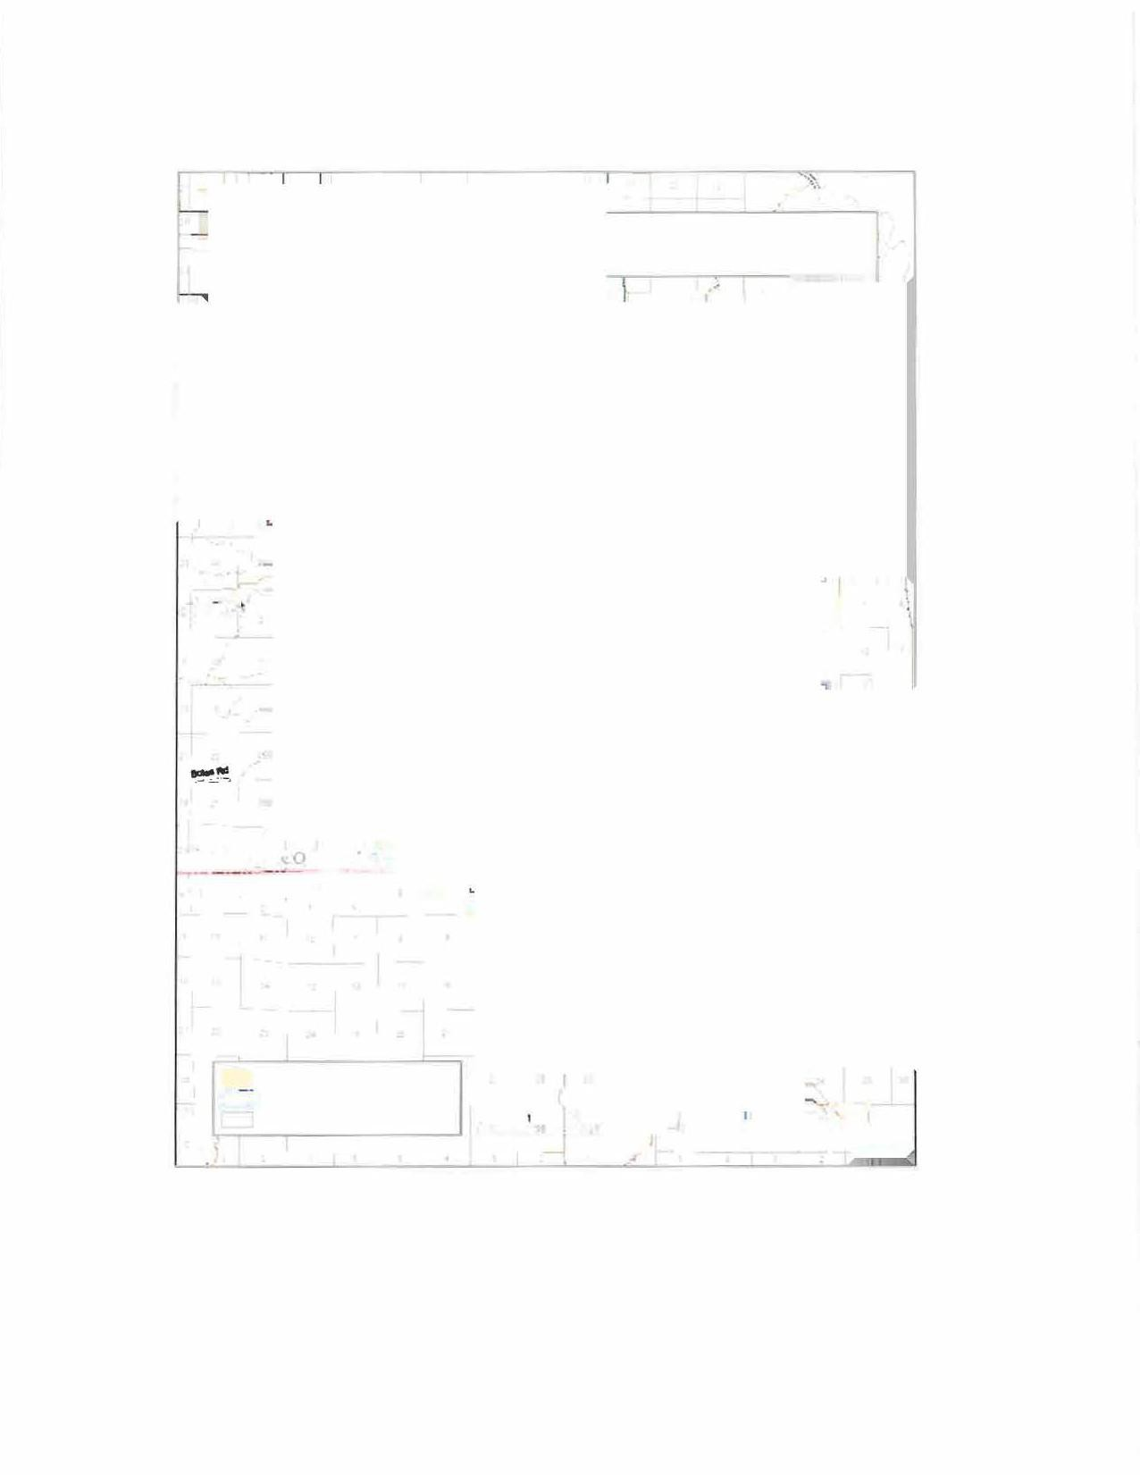
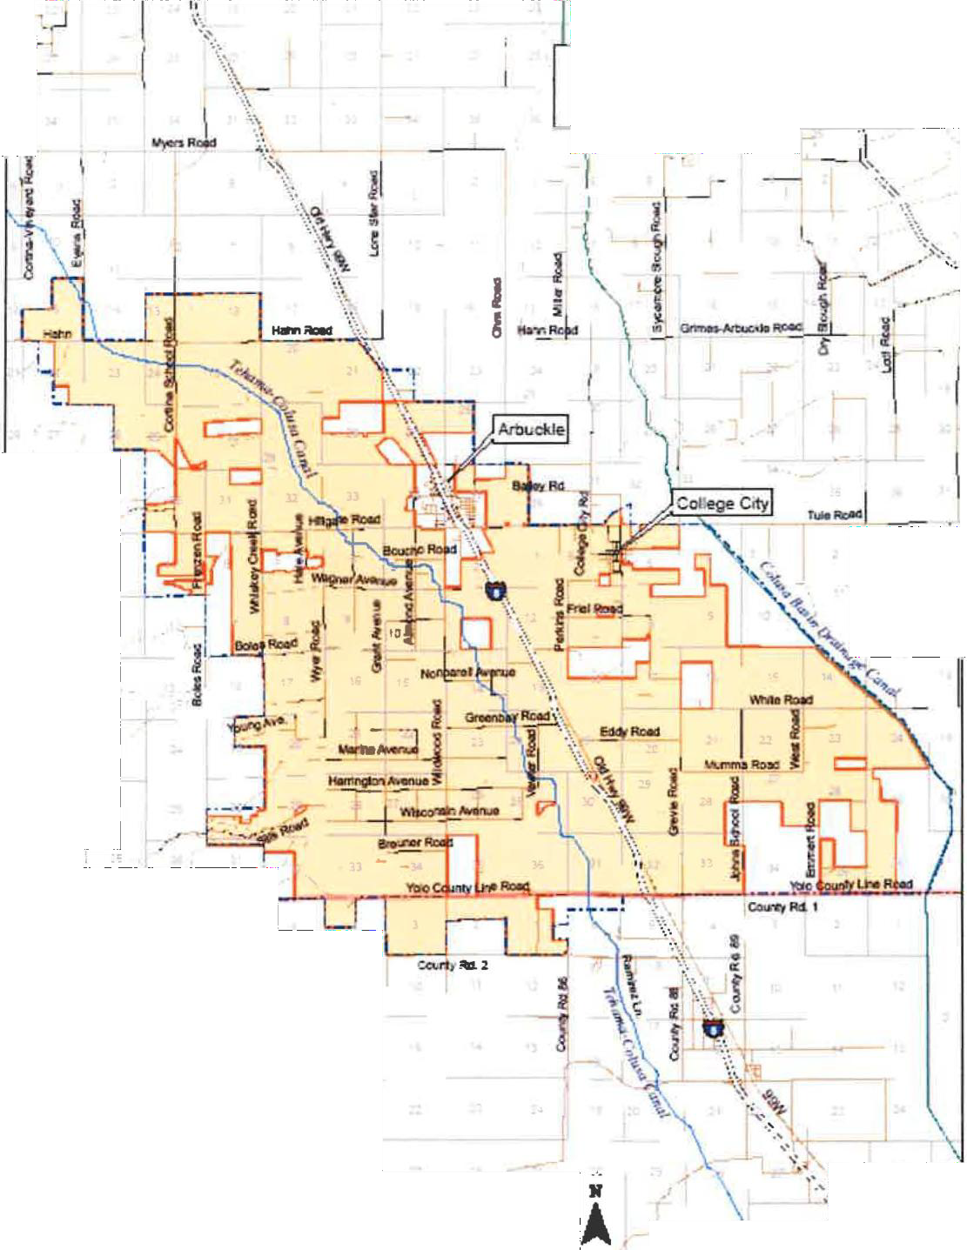
lo

and Sphere of Influence
- -
1
PlaJIII: Lillel SU'ley Seclani D---==::::i2lM&
,,
----C<I-,-. iCGIJ
-L2AFCO1118

Attachment B


ATTACHMENT A - District Maps
SOILS OF COLUSA COUNTY

CALIFORNIA
UNIVERSITY 01' CAUFORNJA • COLLF.Gll OP AGRJCULTIJRll
AGRJCULTIJllAL liXPl.illlMENT STATION
DliRKF.LEY if, CAUFORNIA
-

TERRACE SOIL9
-
S1.1r.l,•.1_Ha1111t,
~-,
JttRr,t•
90IL9 GROUPED NITn
PliYSIOGRAPHIC DIVISIONS
D RECENT ALL\11/IAL FAN AND n.ooo PLAIN SOILS
...,.,l.e,•,..N,.M1•1
-
.,c.___,,._,.,

illillTIJ UP1.Al'ID SOILS
9o,IH "-'
-
,.,,,,.,.
5 , .,_,.

Allnutt/
,,C,.#,,,tt.,f,,.,w,.,,.c.-.
...
,,,_
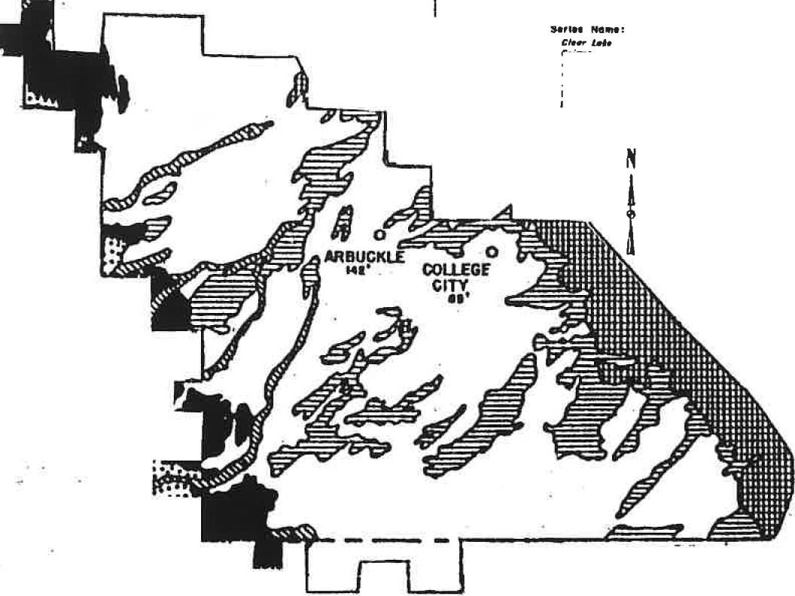
.s,,,.,,,,,,,.,,..,,_
....

r-
r ., ,
r-.
�-

0Ul£R ALLUVIAL FAN SOIL$
Sa,r,l.H,,.,f,t,o,.fftt•
H_,.,,..
11,,r.

Attachment C

COLUSA COUNTY WATER DISTRICT
ORDINANCE NO. 2009-01

AN ORDINANCE OF THE COLUSA COUNTY WATER DISTRICT ESTABLISHING RULES AND REGULATIONS FOR WATER DELIVERY DURING A WATER SHORTAGE EMERGENCY AND ESTABLISHING PENALTIES FOR VIOLATIONS THEREOF

The Board of Directors of the Colusa County Water District, ORDAINS AS FOLLOWS:

- FINDINGS AND DETERMINATIONS
  - The primary source of water for Colusa County Water District ("District") is a water service contract ("WSC") with the federal Bureau of Reclamation ("Reclamation"). The WSC provides for a mechanism for Reclamation to notify the District when there will be a shortage of water available. Shortages can range from 1% to 100%. Under current Reclamation practices, water allocation announcements are made approximately monthly beginning in February and continuing until May or June of each year. The monthly allocation announcements for the District can vary widely. Thus, for example, an announcement in February can be of a 100% allocation to the District, and the announcement the following month can be of a 50% allocation. Likewise, early allocation announcements might be of less than a 100% supply, but in later months, Reclamation may be able to restore the District to a full contract supply for the Water Year. Shortages due to reductions in the WSC supply will be referred to in this Ordinance as "Hydrologic Shortages."
  - Water is generally available all year but the Tehama-Colusa Canal Authority ("TCCA") may restrict or discontinue service during certain periods. Service may be discontinued at any time while maintenance or repair work is being done by Reclamation, TCCA or the District either on the Tehama-Colusa Canal or District facilities. Restrictions in the physical ability or legal authority of Reclamation or TCCA to divert water into the Tehama-Colusa Canal at Red Bluff may also lead to restrictions or discontinuance of service. Shortages for these reasons will be referred to herein as "Conveyance Shortages."
  - The provisions of this Ordinance will apply during times of water shortage emergency, as defined below, in order to conserve and equitably allocate the water supply of the District during such periods of emergency.
- WATER SHORTAGE EMERGENCY
A water shortage emergency shall be deemed to exist when any one of the following has occurred:
  - Reclamation has informed the District that there is a Hydrologic Shortage resulting in an allocation under the District's WSC of 80% or less of the total contractual water

supply. Unless otherwise determined by the District Board of Directors in a particular year, Reclamation's water supply announcement provided to the District on or after April 1 of each year shall be the final determination of whether this Ordinance is in effect for that year.
  - When the District Board of Directors adopts a resolution declaring that a Conveyance Shortage exists.
- WATER ALLOCATION
  - Every person wishing to have District water service must submit an application to the District no later than April 1st each year.
  - District water service is subject to the terms and conditions of the WSC.
  - Each parcel of property within the District for which an application has been timely submitted and which is eligible under federal Reclamation law and the District's WSC and rules and regulations will receive a pro-rata share of the available water supply, based upon the number of assessed acres of that parcel as shown on the books and records of the District.
  - Parcels that the District Board of Directors have approved for annexation to the District, but for which a LAFCO annexation procedure has not yet been completed are entitled to apply for and receive a pro-rata share of the District's water supply.
- WATER RATES
  - In a year in which there is a water shortage emergency due to Hydrologic Shortage, the applicant for water service must pay for the water allocation in full no later than April 15. The District will reallocate pro-rata to other applicants any water for which payment is not received by this date. The application must be signed by both the owner of each parcel of land for which water service is required and the tenant, if any, of each parcel. The Board of Directors will approve the form of the application. Each landowner, by signing the application, gives permission to the tenant to reapply for additional water for the current crop year without obtaining the landowner's signature, and by signing the application, the landowner agrees to be bound thereby.
- EXCESS WATER USE CHARGE AND TERMINATION OF SERVICE
  - Each applicant is responsible to assure that his/her/its water use does not exceed the applicant's water allocation for the year. The District will exercise reasonable efforts to make timely water use information available to the applicant, upon the applicant's request.
  - Applicants who exceed their water allocation will be charged an Excess Use Charge as determined by the District Board of Directors from time to time. The Excess Use Charge may include a charge per acre-foot as well as a charge for re-establishing water service if and when an additional water supply becomes available or at the beginning of the following Water Year.

2

  - In order to protect the District's limited water supply and to assure that the supplies of other applicants are not impaired by an applicant's overuse, delivery to a water user who has used more than his/her/its allocation will be terminated immediately and without notice. The District, however, will give notice to the applicant immediately upon termination of the service and the applicant may appeal to the District Board of Directors to have the service restored if the applicant can prove, to the satisfaction of the Board of Directors, that the applicant has not overused his/her/its allocation.
- WATER TRANSFERS
  - Applications for water transfers must be submitted in writing to the District executed both by the landowner (and tenant, if any) of land for which the water was allocated, and the landowner (and tenant, if any) of the land to which the water is to be transferred.
  - Any water transfer to land outside the District must be approved by Reclamation, in accordance with the Central Valley Project Improvement Act.
  - All water transferred beyond the boundaries of the District will be billed to those landowners or tenants to whom the water was originally allocated. Payment for the water will be made to the District. Persons transferring water will be charged all costs incurred in the transfer.
- TAIL WATER MANAGEMENT
Any water user who deliberately, carelessly, or otherwise wastes water on roads, roadside ditches, adjoining land or drainage channels, will be in violation of these rules. Upon the District's determination that any water user is engaging in such behavior, the District will provide notice of the violation to such water user ("Violation Notice"). The Violation Notice will state a reasonable period oftime to correct the spillage problem, as the District determines in its sole and absolute discretion. If the water user does not timely make the corrections, the District may discontinue water service in accordance with Section 8.
- VIOLATION OF ORDINANCE
  - Except as provided in Section 5, any violation of this Ordinance may, after notice and opportunity to be heard, result in termination of water service.
  - The Notice given in accordance with Section 8.a will include notice that the recipient of the Notice may appeal the termination to the Board of Directors, and the Notice will provide a reasonable period of time for such appeal, before the termination is effected.
  - In accordance with Water Code Section 31029, any violation of this Ordinance is a misdemeanor and the violator, shall, upon conviction, be subject to imprisonment in the County jail for not more than 30 days or by fine of not more than six hundred dollars ($600.00), or by both such fine and imprisonment.
Adopted March 11, 2009

3

Attachment D

COLUSA COUNTY WATER DISTRICT

RULES & REGULATIONS

- Water Service Season

Water is generally available all year round. Service may be temporarily discontinued at any time while maintenance or repair work is done. In the event of a water supply shortage announcement by the U.S. Bureau of Reclamation water is allocated to the users in accordance with the District's Drought Ordinance 2009-1.

- Water Use

The District's water service contract with the Bureau of Reclamation permits water to be used for both agricultural and municipal and industrial purposes. The District does not provide potable water for domestic or water for public health and safety. As such the Bureau's M&I shortage policy does not apply during State declared droughts or reduced allocations by the Bureau. Currently, the M&I service within the District is strictly landscape.
- Application for Water

An annual water order must be received in the office before April 1st of each year. The order will contain an estimate of the water requirement for the irrigation season. Tenants must also submit an application for water service signed by the landowner. In water short years orders may be required by March 1st in order to determine transfer needs.

- Water Rates

Water rates are reviewed annually by the Board of Directors and may be revised when necessary Water rates are considered "pass through" as rates only increase due to changes in the Bureau of Reclamation yearly posted rates and the TC conveyance costs. Rates include charges for the water by the Bureau of Reclamation, operation and maintenance costs, and a reserve fund.

- Payments

The District must pay the Bureau of Reclamation in advance for the estimated water usage for the coming irrigation season. Prior to April 1st the District must receive one-half of each users seasonal estimate. Prior to July 1st the balance of

each estimate is due. Any balance due or credit is determined by final meter readings. No water will be delivered until installments are paid.
- Statements of Accounts

Statements will be sent annually and will indicate quantity of water used, balance due or credit. Credits can be applied to the following irrigation season or refunded on request.

- Delinquent Accounts

Balances due are payable 30 days from date of the statement and become delinquent after this time. Interest at the rate of 1½% per month will be added to delinquent accounts. In the event of tenant default the landowner will bear the responsibility of the balance due plus any added interest. No water will be delivered for any purpose until the delinquent account has been paid in full.
Further, a separate District Assessment Policy denies delivery of water to lands delinquent in assessment payments as well as Base Rate charges.

- Water Orders

Orders for water must be received in the office before 1:00 p.m. the day before starting irrigation. The District must be notified before 1:00 P.M. the day prior to finishing irrigation. While the office is closed, water orders may be placed on a recorder by calling 476-2669. Orders must be placed by delivery number, gallons per minute (GPM) and total hours/days running. During droughts or reduced allocations schedules longer that a week will not be allowed Deadlines for ordering may be changed at any time by the District. Deliveries found taking water with no water order recorded are subject to being shut off.
- Water Delivery

Water ordered will be delivered but may be limited in quantity or delayed in delivery. In the event of an extreme water demand delivery may be granted on a first-ordered, first-served basis. The District cannot and does not guarantee the delivery of water as to the time of delivery, quality or amount.

- Waste of Water

To avoid drainage problems, it shall be the responsibility of every water user to control the water applied to his land. Any water user who deliberately, carelessly or otherwise wastes water on roads, adjoining land or creeks will be informed by District personnel that he is not complying with this rule. He will be allowed a reasonable time to correct the situation. If he makes no prompt effort of correction his water service will be discontinued.

- Connection to District Turnouts

The water user shall at his own expense take water from District turnouts in a manner approved by the District and shall provide all necessary materials and labor. No modifications or additions may be made to District outlets by other than District personnel. To prevent sudden surges and water hammer in District pipelines no rapid-closing valves of any type will be permitted to be installed.
- Right of Access

District personnel shall have right of access, at any time, to deliveries, pipelines, air release valves, and any other District facility for operation, inspection, maintenance or repair. Precautions will be taken to protect trees, crops, soil surface or any other property from damage.

- Land Clearing and Leveling

It shall be the landowner or his agents' (tenant) responsibility to obtain District permission before any clearing, leveling, ripping, changing of water channels, setting of utility poles, excavations for any purpose, or any work performed within District easements. Underground Dig must be contacted at 81l/1-800-227-2600 so that District personnel can be notified to locate and mark pipelines or other District facilities in the area.
- Damages and Repairs

Damage to District property such as aluminum pipelines, air release valves, meters, meter and valve key well, and delivery outlets, caused by reason of acts of omissions of the water user or landowner or his agents, will be repaired by the District and the cost of repairs will be charged to the landowner or water user responsible.

- Metered Water Service

It is the District policy that all water service connections installed hereafter shall contain a metering device. Water available to the District through its water service contract with the United States Bureau of Reclamation is required to be measured at each service connection. Said metering devices must be adequately sized to meter water use as accurately as possible.

- Water Meter Failure

In the event of the failure of a water meter to accurately record the water delivery every reasonable effort will be made to determine accurate water usage and such estimated usage will be charged to the water user's account.

3

- Delivery Areas

Delivery areas shall be kept clean and free from weeds, brush, empty chemical containers and any other debris.

- New Outlets

The District shall not provide additional turnouts or meters to property already served by a District turnout nor to newly created parcels except at the expense of the landowner. This includes modifications (meter replacement) necessary to insure meters are adequately sized to record use. The entire installation including pipelines, valves, meter, etc., shall remain the property of the District. Turnouts to lands hereafter annexed to the District, which connect to existing laterals, will be installed only at the expense of the landowner. Further, any significant modification of an existing delivery at the request of the landowner or to accommodate a change in the property size of a newly created parcel will be done only at the expense of the landowner.

- Tools & Equipment

District-owned tools and equipment will not be loaned.

- Changes in Rules and Regulations

The Rules and Regulations shall become effective immediately and may be added to, amended or repealed at any time by Resolution of the Board of Directors

.Jliopted by the Board of Directors of the Colusa County Water District on March 12, 2014.

Attachment E

COLUSA COUNTY WATER DISTRICT

Rates for 2019

Base Rate (District O&M) or Service Charge:

Assessment fee:
(established in 1986; 9(d) loan debt on pipelines)
$ 24.50 I Acre

$ 9.25 I Acre

Warren Water Purchase Charge Ag Rate M&I Rate Full Cost Act

USSR Cost of Service | 79.71 | 37.08 | 141.01 | n/a
USSR Restoration Fund | 10.63 | 21.26 | 10.63
Trinity PUD Assessment | .30 | .30 | .30
TCCA Conveyance charge | 14.36 | 14.36 | 14.36 | n/a
LT Transfer Differential @75% alloc 1.00 1.00 1.00
Blended Rate

Total Water Charge: $ 106.00 /af $ 74.00 /af $ 167.30 /af $ n/a
(Per Acre-Foot)

Colusa County Water District PO BOX337
Arbuckle, CA 95912

Water Statement
Page:

Attachment E

(530) 476-2784 Statement Date: 12/31/2019
Customer Number: 00-0002005

ABELE RANCH, JS
P.O. BOX2 ARBUCKLE, CA 95912

Date | Reference | Description | Acre Feet Used | Price Per Acre Foot | Charge | Credit | Running Balance
4/30/2019 | 0022326-IN | April Use | 21.00 | 106.00 | 2,226.00 |  | 82,575.10-
5/31/2019 | 0022483-IN | May Use | 31.00 | 106.00 | 3,286.00 |  | 79,289.10-
6/30/2019 | 0022642-IN | June Use | 92.00 | 106.00 | 9,752.00 |  | 69,537.10-
7/31/2019 | 0023030-IN | July Use | 93.00 | 106.00 | 9,858.00 |  | 59,679.10-
8/31/2019 | 0023238-IN | August Use | 59.00 | 106.00 | 6,254.00 |  | 53,425.10-
9/30/2019 | 0023588-IN | September Use | 33.00 | 106.00 | 3,498.00 |  | 49,927.10-
10/31/2019 | 0028545-IN | October Use | 38.00 | 106.00 | 4,028.00 |  | 45,899.10-
11/30/2019 | 0028720-IN | November Use | 18.00 | 106.00 | 1,908.00 |  | 43,991.10-

Total Charged Total Paid Customer Balance

40,810.00 0.00 43,991.10-

Water will be terminated on Delinquent Accounts Past due will be sent to County for Collection

Colusa County Water District Water Invoice
PO BOX337
Arbuckle, CA 95912
(530) 476-2784
Page:

Attachment E

Bill to:
ABELE RANCH , JS
P.O. BOX2
ARBUCKLE, CA 95912

Owner:

Invoice Number: 0023030-IN

Invoice Date: 7/31/2019

ABELE RANCH , JS Customer Number: 00-0002005

Item Code/Description |  | Meter | Acre feet | Price | Amount
WATER | July water use | 125A | 3.000 | 106.000 | 318.00
WATER | July water use | 14 | 18.000 | 106.000 | 1,908.00
WATER | July water use | 17 | 30.000 | 106.000 | 3,180.00
WATER | July water use | 190A | 24.000 | 106.000 | 2,544.00
WATER | July water use | 913 | 18.000 | 106.000 | 1,908.00

Total Usage: 93.00

To Ensure Proper Credit Please Return Copy with Customer#.

Net Invoice: | 9,858.00
Invoice Total: | 9,858.00

COLUSA COUNTY WATER DISTRICT
Attachment
2019
Crop Report & Water Request Form
Name/Entity: EmaiI:
Phone:

Include all District acreage with crop grown or fallow whether or not District water is used. This is required for Bureau Crop Report
Irrigation Type Yr. Total AF

--
No. Parcel No.'s Landowner Crop | BSorpdreklrr,,FDurirproowr ,  MicroSprklr | Acreage | P(lpaenrtmed crops) | or Well use
B | F s D McSp |  | P(lpaenrtmed crops)
B | F s D McSp
B | F s D McSp
B | F s D McSp
B | F s D McSp
B | F s D McSp
B | F s D McSp
B | F s D McSp
B | F s D McSp
B | F s D McSp
B | F s D McSp

1
--
2

3

4

5

6

7

8

9

10

11

- B F s D McSp --
Total AF Needed
Total AF

1/2 Due by April 15th
+/- Credit or water balance due
-
Total Due by April 15th
Balance Due by July 1st
Completion and submission of this form does not guarantee full request will be available.
If a reduction in request is necessary you will be contacted directly by the District office.

---------- 3/
�

(sea111etr1cs
•• �JsJon now HHsu-t ::_: :···
Attachment F

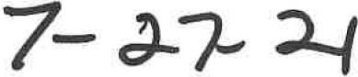
CALIBRATION REPORT


CALIBRATION ID
Serial Number: 04213352  Sensor Type: AG3000-800-Fl-BX-X-01  Nominal K-Factor: 11.67  Date: 2021-05-20 12:38  Test Result: PASS | 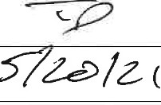  Signature:
 | Date:

CALIBRATION RESULTS
No. | Time | Avg. Temp. | Full Scale Flow | Actual Flow Rate | Measured K-Factor | % Deviation of K-Factor from Nominal | Expanded  Uncertainty•
 | [sec] | [CJ | [%] | [gpm] | [ppg] | [%] | [%]
I | 30.00 | 22.58 | 40.2 | 2065.667 | 11.68 | 0.04 | 0.30
2 | 30.00 | 22.58 | 40.2 | 2066.301 | 11.67 | 0.00 | 0.30
3 | 30.00 | 22.58 | 40.2 | 2067.654 | 11.64 | -0.25 | 0.30
4 | 51.86 | 22.56 | 1.9 | 99.336 | 11.69 | 0.11 | 0.30
5 | 51.85 | 22.56 | 1.9 | 99.057 | 11.67 | 0.00 | 0.30
6 | 51.85 | 22.56 | 1.9 | 99.547 | 11.65 | -0.20 | 0.30

12.0

11.9 ·

11 8


11 6

l1 'S

l l..S

1000 ;>000 3000
flow Rate (9pm)

4000 5000

*NOTES:
- Expanded uncertainty= 2*(standard uncertainty arising from random effects). Coverage factor was 2.
- K-Factors were measured prior to calibration. Values listed herein were adjusted to reflect meter calibration.
- K-factor and flow rate measurements are traceable to NIST through an unbroken chain of measurements.

Seametrics • 19026 72nd Ave South • Kent, Washington 98032 • USA
(P) 253.872.0284 • (F) 253.872.0285 • 1.800.975.8153 • www.Seametrics.com


Prt!cJs'- Row�-t
<seaniiir1cs
Attachment F


A,,eO,.WC.0,,�.,,,,, CALIBRATION REPORT

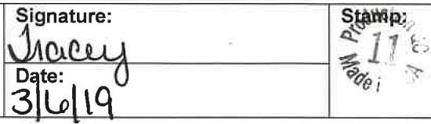
CALIBRATION ID
Serial Number: 012019002660
Sensor Type: AG3000-800-Fl-BX-X-01
Nominal K-Factor: 11.67
Date: 2019-03-06 07:29
Test Result: PASS
CALIBRATION RESULTS
No. | Time | Avg. Temp. | Full Scale Flow | Actual Flow Rate | Measured K-Factor | % Deviation of K-Factor from Nominal | Expanded Uncertainty*
 | [sec] | [CJ | [%] | [gpm] | [ppg] | [%] | [%]
1 | 30.00 | 22.37 | 40.2 | 2064.880 | 11.67 | 0.00 | 0.30
2 | 30.00 | 22.37 | 40.2 | 2065.988 | 11.68 | 0.07 | 0.30
3 | 29.99 | 22.37 | 40.2 | 2067.052 | 11.67 | -0.00 | 0.30
4 | 51.85 | 22.37 | 1.9 | 99.533 | 11.67 | 0.00 | 0.30
5 | 51.85 | 22.37 | 1.9 | 99.620 | 11.67 | 0.02 | 0.30
6 | 51.85 | 22.36 | 1.9 | 99.451 | 11.67 | -0.02 | 0.30

12 0

119

11.8
j

� 11 7
V
:! 8
""'

T,&."<..,t f

11 6

11 '.>

I 0v

11 4

1000 2000 )000
Flow Rate (gpml

-IOOO 5000

*NOTES:
- Expanded uncertainty = 2*(standard uncertainty arising from random effects). Coverage factor was 2.
- K-Factors were measured prior to calibration. Values listed herein were adjusted to reflect meter calibration.
- K-Factor and flow rate measurements are traceable to NIST through an unbroken chain of measurements.

Seametrics • 19026 72nd Ave South • Kent, Washington 98032 • USA
(P) 253.872.0284 • (F) 253.872.0285 • 1.800.975.8153 • www.Seametrics.com

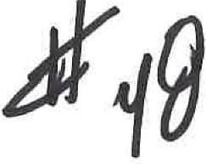
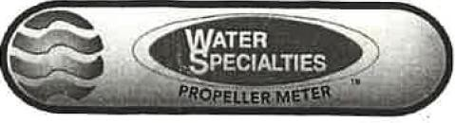
Attachment F

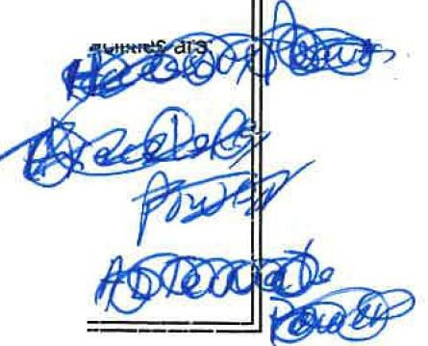
CERTIFIED TEST REPORT

CUSTOMER: TECHNOFLO SYSTEMS
MODEL NO: ..M...L.. 04- oa _
METER SERIAL NO: -2.0.1 . ..,.4..1...841 _

CONFIGURATION
METER INSIDE DIAMETER: -=-B-=0=95:::..... _
DIAL: AFT X 0.001 1500 GPM
GEARS: =24-"---'-/-'4---0 _
TOTALIZER GEARS: -'-'X=23=Z"-'-/-'-X1 5 _
ACTUAL METER INDEX: _0_.4_00_7 ,

TEST FACILITY: --'V olu me tric'------------

CALIBRATION DATA
FLOW RATE %
GPM ACCURACY
1 | 1473.67 | 101.58
2 | 756.40 | 101.95
3 | 195.30 | 101.02

L

CERTIFIED BY: P.a.;;u.;l;..H;;.o;;.b;;b...s.;;...;;....;;..;�..c...,_-------
TEST DATE: 7/16/2014
PRINT DATE 7_/1_6_/2_0_14

This calibration was performed on a primary or secondary test facility, traceable to the National Institute of Standards and Technology, USA. The estimated flow measurement uncertainty of the calibration • • •
Primary +/- 0.15% Secondary +/- 0.5%

@ McOl01\1EfER
3255 WEJT sn:TSOM AVENUE HEMET, CA 92543 USA
PHONE (951) 652-6311 / FAX (9�·1) 652-3078
WEB SITE: http://www.mccrometer.com E-MAIL: cu:.tomerservlc�@mccromet:ir.com

I n11111m1U\lll!!!��J!�

\IN111111-

Printed by Ramiro D. Hernandez
7/16/2014 5:16:27 PM
Version 1.0 (3/9/2007)

Attachment F IM-VFT1-4A-0587


CORPORATION

4"-20"
VERTICAL UPFLOW METERS
MODELS
VF-27, VF-28, VF-29, VF-30

INSTRUCTION MANUAL PARTS AND PRICE LIST

FEATURING:
- STANDARD TOTALIZER ASSEMBLY
*MODEL CN-06-2 INDICATOR-TOTALIZER
*CERAMIC BEARING CARTRIDGE PROPELLER

WATER SPECIALTIES CORPORATION
. 191 W. POPLAR AVE. PORTERVILLE, CALIFORNIA 93257 U.S.A.
j PHONE 209-784-3544
TELEX 230-176771 WATERSPEC
FAX 209-784-1787

IM-VFT1-4A-0587

4"-20"
VERTICAL UPFLOW METERS
MODELS VF-27, VF-29
*STANDARD TOTALIZER ASSEMBLY
*CERAMIC BEARING CARTRIDGE PROPELLER

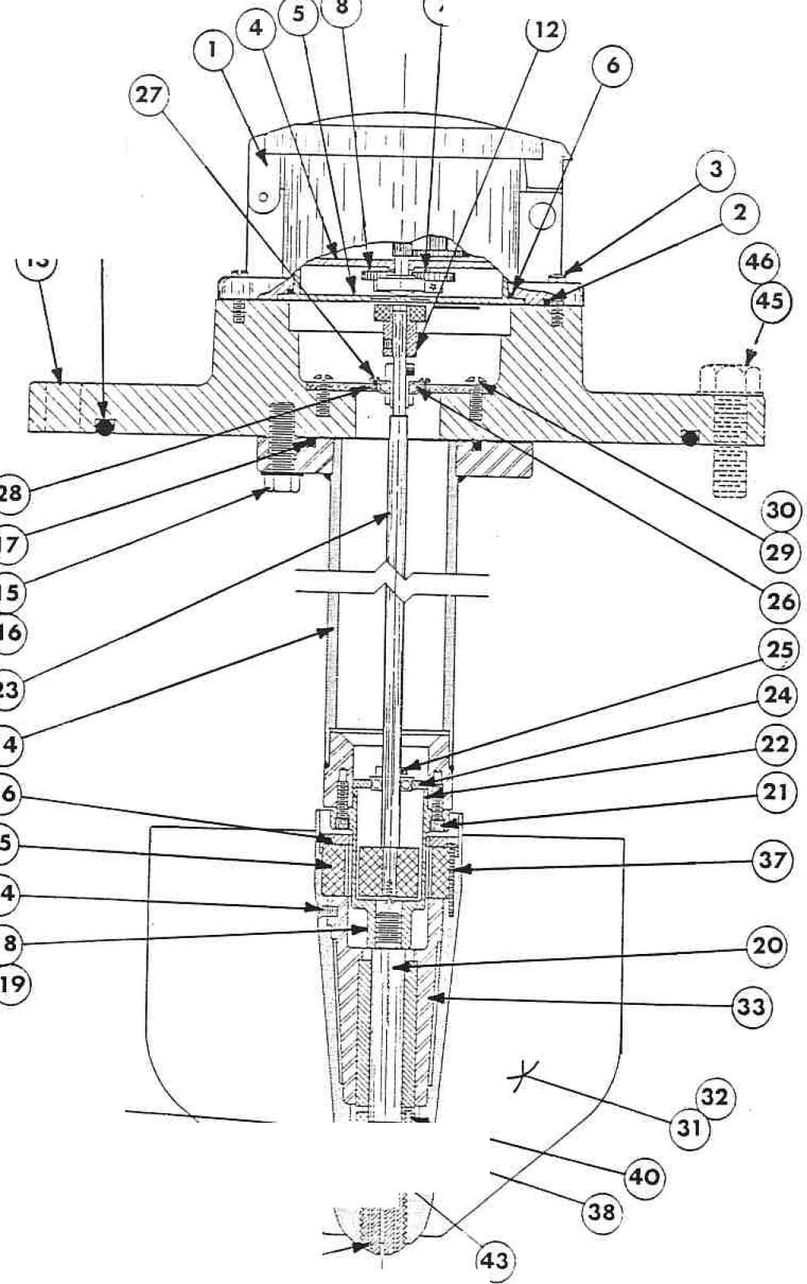

J

IM-VFT1-4A--0587

VERTICAL UPFLOW METER INDEX
- UNCRATING
- INSTALLATION
  - Model VF-27 and VF-28
  - Model VF-29 and VF-30
Ill. METER SERVICE SCHEDULE
- Standard Totalizer. Yearly Inspection
- Standard Totalizer. Every Five Years
*3. Indicator-Totalizer. Yearly Inspection
*4. Indicator-Totalizer. Every Five Years
- METER HEAD ASSEMBLY
- WORKING AREA
- TOTALIZER ASSEMBLY
  - Bonnet Mounting Screws
  - Totalizer
  - Totalizer Change Gears
  - Totalizer Drive Magnet
*VII. INDICATOR-TOTALIZER
*1. Bonnet Mounting Screws
*2. Indicator Mounting Screws
*3. Meter Change Gears
*4. lndicator-Totalizer
*5. Gears
- VERTICAL SHAFT ASSEMBLY
- PROPELLER ASSEMBLY
  - Propeller Removal
  - Water Lubrication
  - Ceramic Bearing Cartridge
  - Support Spindle
  - Separator Removal
  - Propeller Installation
  - Thrust Bearing Cartridge
  - Bearing
- INSPECTION
XII. REASSEMBLY
- Vertical Shaft Assembly
- Totalizer Drive Magnet
- Totalizer Base Cup
- Totalizer Bonnet Assembly
*5. Change Gears
*6. Indicator-Totalizer
*7. Indicator-Totalizer Bonnet
- Propeller Assembly
- Meter Head O-Ring or Gasket

*For Indicator-Totalizer Models Only
3
VERTICAL UPFLOW METER INSTALLATION

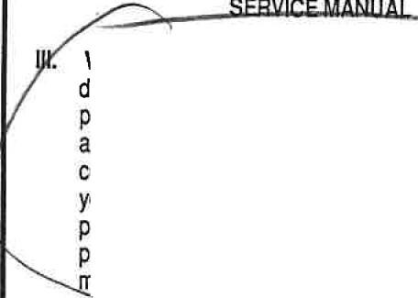

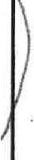
L UNCRATING. When uncrating the meter, any damage due to rough or improper handling should be reported to the transportation firm and Water Specialties. If for any reason, it is determined that the unit or parts of the unit should be returned to the factory, please contact Water Specialties tor clearance prior to shipment. Each unit must be properly crated to prevent any further damage. The factory assumes no responsibility for equipment damage in return shipment due to Improper packaging. The shipping crate contains the following items:
Vertical Upflow Meter with
Standard Totalizer (VF-27 or VF-29) ....... Vertical Upnow Meter with
CN-06-2 (VF-28 or VF30) ..................
Mounting Equipment as required ............. Service Manual 1
- INSTALLATION of Water Specialties Vertical Upflow Meters varies depending upon the type and model of meter selected for each application. The meter must have a full flow of liquid for proper accuracy. The meter installations fall tnto two basic categories:
  - MODEL VF-27 and VF-28 are designed to allow installation to an appropriate cast iron or fabricated steel tee. These tees usually replace an elbow in existing systems. Valves, fittings, or other obstructions that tend to set up flow disturbances should be a minimum of five pipe diameters upstream from meter location.
  - MODEL VF-29 and VF-30 TEE can be installed similar to placing a Hanged elbow or tee in the line. Installation can be made to any vertical discharge concrete turnouts with proper anchor bolts. The meter must be installed upright for a full flow of liquid through the pipe to assure proper accuracy. Valves, fittings, or other obstructions that tend to set up flow disturbances should be a minimum of five pipe diameters upstream from the meter location.
VERTICAL UPFLOW METERS

WATER SPECIALTIES products have been carefully designed to be as maintenance free as possible. Periodic preventive maintenance, however, ishighly recommended and should be practiced according to schedule to assure continuous accuracy and trouble-free performance of your propeller meters. The maintenance and inspection procedure can also be used as a guide to locating a problem in the unit that may be the cause of abnormal meter operation.
- METERS WITH STANDARD TOTALIZERS.
YEARLY INSPECTION should be practiced on all meters but should not require complete disassembly of the meter. It should however include, cleaning, and inspection of the propeller and bearing. (see steps IV, V, IX-1 thru 8, X, and Xl-8 & 9)

IM-VFT1•4A-0587

- METERS WITH STANDARD TOTALIZERS. EVERY
FIVE YEARS meters should be completely disassembled and inspected to assure dependable service Jrom the meter, and to eliminate any problems that could lead to costly repairs. Follow all steps (except• steps).
•3, METERS WITH INDICATOR-TOTALIZERS.
YEARLY INSPECTION should be practiced on all meters but should not require complete disassembly of the meter. It should however include cleaning and inspection of the propeller, indicator-totalizer and bearing. (see steps IV, V, Vll-1, 2, 3, & 5, IX-1 thru 8, X, and Xl-5 thru 9)
*4. METERS WITH INDICATOR-TOTALIZERS. EVERY
FIVE YEARS meters should be completely disassembled and inspected to assure dependable service from the meter, and to eliminate any problems that could lead to costly repairs. (see steps IV, V, Vll-1 thru 5, VIII, IX-1 thru 8, X, Xl-1 & 5 thru 9)
- METER HEAD ASSEMBLY should be removed from the tee or meter tee tube by removing the meter head bolts (#45) and lifting the entire head assembly upward, taking care not fo damage the propeller assembly as it is pulled clear of the tee Hanged end. Inspect the meter head a-ring (#44) or flat gasket for any signs of damage and replace if necessary. Replace the meter head assembly with a dummy cover plate if the service line is to remain in operation. ,
- WORKING AREA chosen for disassembly and reassembly of the internal meter components should be clean to reduce the chance of dust or dirt particles being introduced into the meter mechanism.
- TOTAUZER ASSEMBLY (#4) service prodedure should include cleaning and inspection of the unit noting any excessive wear on the change gears (#7 & #8) that may lead to operational problems iri the unit.
  - BONNET MOUNTING SCREWS (#3) should be
removed and the entire bonnet (#1) lilted off of the meter.
  - TOTALIZER is contained within the totalizer bonnet (#1) and held in place by a base cup (#5). It should not be necessary to remove the totalizer (#4) during inspection; however, removal of the base cup (#5) is necessary for inspection of the totalizer change gears (#7 & #8). Removal of the base cup (#5) can be accomplished by inserting a small screwdriver into the two cutouts and prying upward under the edge.
  - TOTALIZER CHANGE GEARS (#7 & #8) should be
inspected for any sign of wear. Both the A-(drive) gear and 8-(driven) gear are attached to the lower portion of the totalizer assembly (#4). Spin the floating totalizer driven magnet in the center of the totalizer bottom (#4) to make certain it spins freely without bind or drag. The bottom of the totalizer has the letter
A molded next to the A-drive gear shalt, and the letter
B next to the 8-driven gear shalt.

4
  - TOTAUZER DRIVE MAGNET ASSEMBLY (#12}
located in the meter head (#13) at the top of the vertical shaft assembly (#23) should be checked and adjusted ii necessary to position it 1/16 inch below the top surface of the meter head (#13). Adjustments can be made by loosening the socket head set screw in the side of the totalizer drive magnet assembly (#12), and sliding it up or down the vertical shaft (#23) as desired. Always be sure the set screw is tightened into the flat on the vertical shaft (#23).
·vn. INDICATOR-TOT AUZER service prodedure should be practiced every year and should include removal, cleaning and inspection of the unit noting any excessive wear on the gears and other wear points that may lead to operational problems in the unit.
*1. BONNET MOUNTING SCREWS (#2) located '
beneath the indicator-totalizer bonnet lid, should be removed and the entire bonnet (#1) lilted off of the meter. Replace the a-ring seals around each of the lour screws (#3) and at the bottom of the bonnet (#4) and cover each of the new a-rings with a thin coat of silicone grease.
*2. INDICATOR MOUNTING SCREWS (#6) and
shakeproof washers (#7) holding the indicator-totalizer unit (#5) to the meter head (#13) should be removed and the unit lilted off, exposing the A-drive gear (#11) attached to the top of the vertical shaft (#2�)-
*3. METER CHANGE GEARS should be inspected for any sign of wear. The A-(drive) gear (#11) is attached to the top of the vertical shaft (#23), and the B· (driven) gear (#12) is attached to the bottom of the indicator (#5}. The position of the A-drive gear should be checked and adjusted if necessary to position the top face of the gear 1/8 inch below the top surface of the meter head (#13). The position of the B-driven gear top face should be 1/8 inch below the bottom of the indicator-totalizer.
*4. INDICATOR-TOTALIZER unit (#5) should be cleaned thoroughly using a mild soap and a soft brush. Under no circumstances should the entire unit be immersed in the soap or should any metal object be used when cleaning and inspecting the internal parts of the indicator-totalizerunit.
*5. GEARS within the indicator-totalizer unit (#5) should be inspected carefully. If any excessive wear is visible on the gear teeth, and other wear points, the unit must be returned to Water Specialties for repair.
- VERTICAL SHAFT ASSEMBLY (#23) is pulled
directly out the top of the meter after removing two screws (#29} inside the meter head (#13} holding the vertical shaft support plate (#28) and bearing assembly (#26) to the meter head (#13). Spin both the upper bearing assembly (#26) and the lower
bearing assembly (#24) gently, checking for any sign of )
wear. Inspect the vertical shaft assembly (#23) to be sure it is not bent or damaged.
*For Indicator-Totalizer Models Only

Attachment F
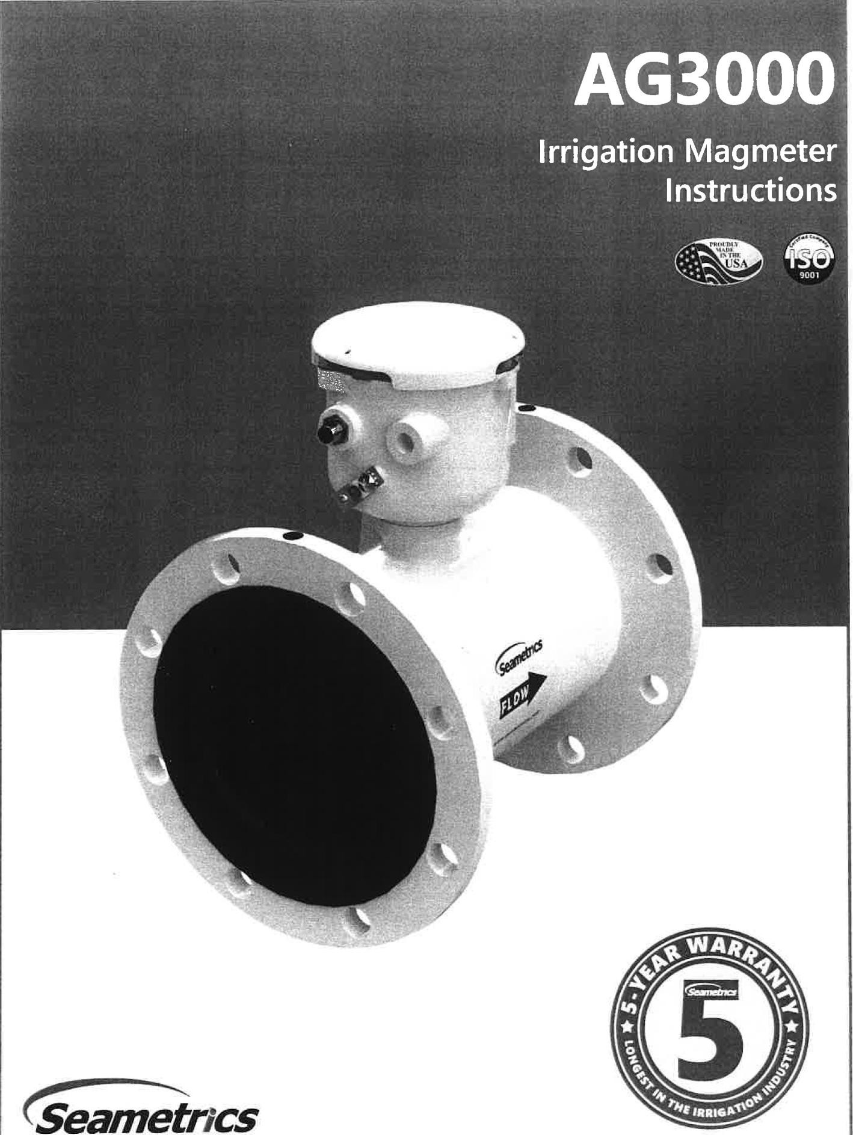
Free battery replacement at year rlVe with warranty registration!

GENERAL INFORMATION AG3000 INSTRUCTIONS

The AG3000 Series is a spool-type electromagnetic flowmeter for use in irrigation applications in 2" to 12'' pipe. With no moving parts, these meters provide unobstructed flow and are resistant to wear from debris found in ground or surface water.Little maintenance is required because there are no bearings to wear out or propellers to stop turning. Minimal straight pipe requirements allow AG3000 meters to be used in piping configurations where there is little space between the meter and an elbow.
The standard AG3000 is battery powered with an available pulse output. Both rate and total indication show on the meter mounted display. Bidirectional flow reading is standard with totals available in forward, reverse, net flow, batch forward flow, and batch reverse flow. Batch totals can be reset. Built-in data logging is available as an option for secure flow logging.
The AG3000 is also available with external DC power. With an externally powered AG3000 an additional output can be added, such as 4-20mA, or Modbus". The battery powered model is available with Modbus® but will shorten battery life.
The AG3000 Series is CE certified and IP68 for burial, or applications where the meter may be under water for prolonged periods of time. All meters are provided with a security seal to protect against unauthorized access. The seal can be broken by an authorized agent to replace the battery pack. The cable is field installed where external power is available and/or an output is needed.
Battery powered Modbus available in April 2021.

Features

Rate and total indicator with light sensor • •
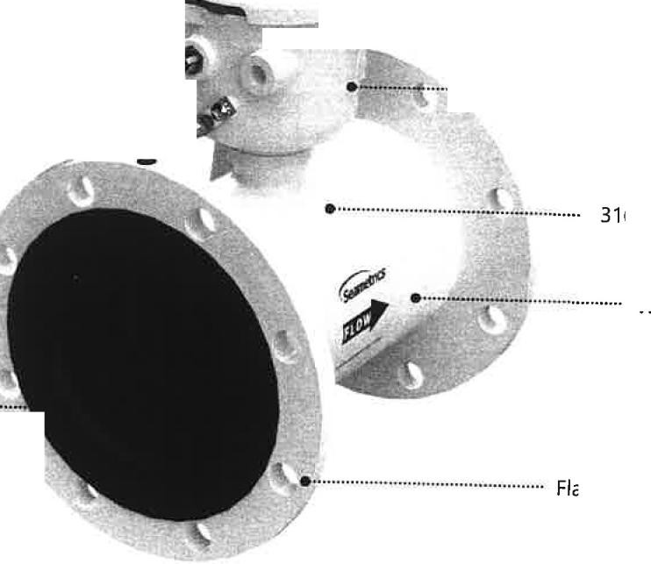
button controls protected by hinged cover

Power and Output cable ••••••••••••••••••••••••••••••••••••••••••••••••••••••••••••••••••••• . port access
Equalization lug ........................................................................................

,:•····"········•·"···"····"···· User access lid
\,.,.;:,...:...-""' Data I�rJtn���h(�i�j

- ········..········ Powder-coated diecast
aluminum electronics
housing 3165S electrodes (Inside)
Welded steel epoxy-coated flow tu6e (Ductile cast iron flow
tube, 3" only)

Santoprene/Polypropylene Liner •"··
(Polyurethane/Nary!" Liner, 2" only)

Flanges, 150 lb. ANSI pattern

AG3000

Seametrics • 253.872.0284 Page 3 seametrics.corn

GENERAL INFORMATION AG3000 INSTRUCTIONS

Specifications*

Pipe Sizes |  | 2", 3", 4", 6", 8", 1O", 12" (2" AVAILABLE IN MAY 2021)
Flanges |  | 150 lb. ANSI Pattern
Pressure |  | 150 psi (10.3 bar) line pressure
Temperature | Operating | 10· to 140" F (-12" to 60" C)
Temperature | Storage | -40" to 158" F (-40" to 70" C)
Accuracy |  | ±0.75% of reading on AG3000p and AG3000r (± 1.0% AG3000), ±0.025% of full-scale flow from low flow cutoff to maximum flow rate of 10 m/sec
Low Flow Cutoff |  | 0.5% of maximum flow rate
Material | Body /2"-72'J | Welded steel, epoxy-coated
Material | Liner (2" & 3'J | Polyurethane/Nary!'"
Material | Liner (4"- 72'J | Santoprene flange/Polypropylene liner body
Material | Electronics Housing | Powder-coated diecast aluminum
Material | Electrodes | 316 stainless steel
Display | Type | 128x64 dot-matrix LCD
Display | Digits | 5 Digit Rate |  |  | 8 Digit Total
Display | Units | Rate Volume Units |  | Rate Time Units | Total Volume Units
Display | Please Note:  All AG3000 meters are factory set for gallons per minute (GPM) rate and acre feet total. If other units are required, they can be set in the field. | Gallons Liters  Barrels(42 gal) Cubic Feet Cubic Meters | Million Gallons' Mega Liters' lmfierial Gallons Mi lion Imperial  Gallons2 | Second Minute Hour Day | Gallons Barrels (42 gal) Acre Feet Gallons x 10 Cubic Meters Acre Inches Gallons x 100 Cubic Meters Imperial Gallons Gallons x 1000 X 1000 Imperial Gallons Million Gallons Cubic Feet X 1000 Liters Cubic Feet x 1000 Million Imperial Kilo Liters Second Foot Day Gallons Mega Liters Million Cubic Feet Fluid Ounces
Display | Bidirectional' | Forward Total, Reverse Total, Net Total, Batch Forward Total, Batch Reverse Total (Batch totals can be reset)
Power | DC Power | 9-36 Vdc @ 250 mA max, 30 mA average 6
Power | Battery Backup  (Not for use as primary power) | AC powered units: One 9V alkaline battery, replacea le.  DC powered units: One lithium 7.2V 'D' size battery ack, replaceable.
Power | AC Power | 85-264Vac, 50/60Hz, 0.12A (AG3000p and AG3000r only)
Power | Battery | One lithium 7.2V 'D' size battery pack, replaceable. (AG3000 only)
Scaled Pulse Output | Signal | Current sinking pulse, isolated, 36 Vdc at 10 mA max
Scaled Pulse Output | Pulse Rates | User-scalable from 0.1 to 99,999.9 volume units/pulse. Pulse width is one-half of pulse peri.od -with minimum pulse w_idth of 2.5 ms, 200 pulses/sec max. For battery option meters, pulse width varies with frequency, 1SO pulses/sec max.
Options | 4-20mA Current Loop | Isolated, passive, 24Vdc, 650 f.l maximum current loop
Options | HART/4-20mA | HART protocol over 4-20mA line (AG3000p & AG3000r only)
Options | High Speed Digital | Isolated, open collector, 24 Vdc (AG3000p only)
Options | Serial Communications | Isolated, asynchronous serial RS485, Modbus® RTU protocol
Conductivity |  | >20 microSiemens/cm
Empty Pipe Detection |  | Hardware/software, conductivity-based
Regulatory |  | CE (EN 61326)
Environmental |  | NEMA 6P, IP68 (10ft (3m) depth, continuously)
Modbus is a registered trademark of Schneider Electric.
* Specifications subject to change. Please consult our website for the most current data (www.seametrics.com).
' If forward and reverse flow data needs to be sent to another device, either the Digital or Modbus output is required.
2 Rate Time Unit is available in Day only

Seametrics • 253.872.0284 Page 4 seametrics.com

UC University lf California
Attachment G

Meeting Announcement

···--- .. April 2018

CE Agriculture and Natural Resources Cooperative Extension

NICKELS SOIL LAB ANNUAL FIELD DAY
Tuesday, May 8, 2018 Marine Ave, Arbuckle, CA
0.75 hr PCA CE credits requested; 2 hours CCA CE credit requests

8:30 am - Registration
Coffee and Donuts provided by Farm Credit Services of Colusa-Glenn, ACA Cycle I: 9:20-10:45 am
  - Overview of navel orangeworm management
Dani Lightle, UCCE Advisor, Glenn/Butte/Tehama Counties
  - Band canker management
Themis Michailides, Plant Pathologist and Lecturer, UC Davis Plant Pathology Department
  - Frost protection in almonds
Joe Connell, Farm Advisor, UCCE Butte County (emeritus)
  - Almond flower biology
Tom Gradziel, Professor, UC Davis Department of Plant Sciences
Cycle II: 10:45 am -12:10 pm
  - Basic Bee Biology 101
Elina Nino, Extension Specialist, UC Davis Entomology and Nematology Department
  - Ceratocystis canker: diagnosis and management
Florent Trouillas, Extension Specialist, UC Davis Plant Pathology Department

  - Using real time physiological data to guide irrigation scheduling.
Tom Buckley, Professor, UC Davis Department of Plant Sciences
  - What are we learning from orchard biomass (chip and mix) studies?
Emad Jahanzad, Postdoctoral researcher, UC Davis Plant Sciences Department

12:15 pm -BBQ Tri-Tip Lunch by reservation.

Luncheon Speaker-Mark Jansen, President & CEO, Blue Diamond Growers
.....
......

UCCE Colusa County• 100 Sunrise Blvd. Suite E • P.O. Box 180 • Colusa, CA 95932 Office 530-458-0570 • Fax 530-458-4625 • Website http://cecolusa.ucanr.edu

10/28/21, 2:24 PM Cal Poly - ITRC - About Us

ABOUT ITRC

Faculty & Staff> , Facilities >
Attachment G

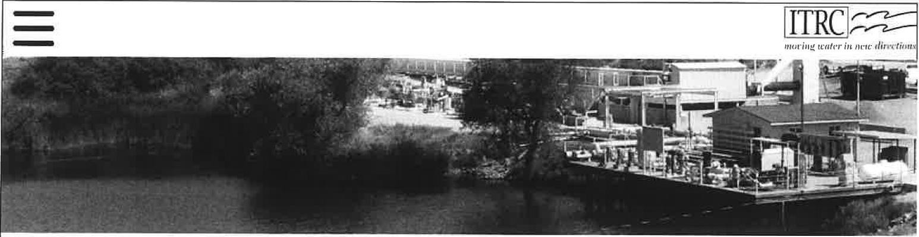
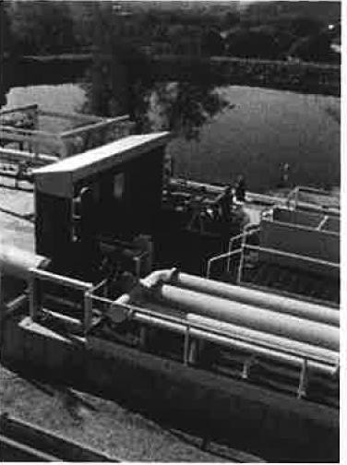
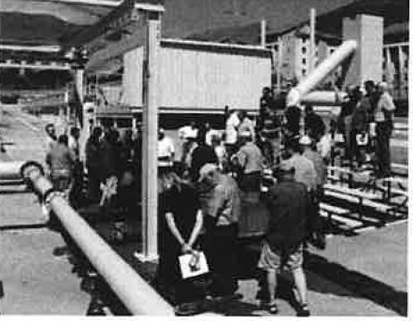

ITRC is a center of excellence housed within the BioResource and Agricultural Engineering (BRAE) Department of California Polytechnic State University (Cal Poly) in San Luis Obispo. The linkage to the BRAE Department is unique among irrigation centers
- ITRC's organization was specifically developed as such to ensure long-term positive benefits to Cal Poly's academic irrigation teaching program - which provides long-term benefits to California and the nation.

Cal Poly has a long tradition of providing pragmatic irrigation training and technical expertise to industry, farmers, irrigation districts, and state/federal agencies. ITRC was officially formed in 1989, and continues to be self-supporting through contracts. Its work is approximately 65% direct technical assistance, 15% training, and 20% research (both applied government-funded, and industry). Focus areas include:

  - Irrigation projects (irrigation district modernization, water balances, river basin return flow issues, SCADA, canal automation, pump automation, flow measurement, energy consumption, and efficiency);
  - Farm irrigation (drip, surface, and sprinkler irrigation; drainage; salinity; energy consumption; irrigation evaluations; evapotranspiration; pumps);
  - Landscape (primarily development of urban water conservation programs).

ITRC's modern engineering offices, in
addition to providing professional resources for ITRC staff, also house two training rooms and office space for both graduate and undergraduate students. Outdoors is the unique Water Resources Facility to demonstrate pumps, pump testing, flow measurement, SCADA, and canal automation. Additionally, the outdoor Irrigation Practices Field contains a complete assortment of on-farm and landscape irrigation systems and equipment.

The center is run by Dr. Charles Burt (Chairman and Founder) and Dr. Stuart Styles (Director) - both recognized internationally as irrigation experts - with an excellent professional staff of 13 persons. Additionally, 15-25 students are hired at any one time to provide support. ITRC utilizes specialists from within and outside
the university to provide additional expertise. As an example, ITRC has worked for several years with an international team to develop sophisticated canal automation algorithms.

ITRC is active throughout the western U.S. and the world in irrigation research, technical assistance, and environmental/energy assessments. For example:

www.itrc.org/about.htm 1/2


PROGRAM SCHEDULE SITE DESCRIPTIONS
aA1lmo�nd Btola�rd orcCJollslornia

AG TECH DAY

Innovations in Ag Irrigation Technology Demonstration and Showcase on Oct. 29, 2021

7:00 a.m. - Registration Opens / CIT Office Registration, CEUs, and Bus Assignments
8:00 a.m. - Welcome / with CIT Director, Charles Hillyer
8:15 a.m. - Buses Depart to Field Sites
8:35 a.m. - Field Site 1: "Groundwater Recharge" with Guest Speakers, Cordie Qualle of California Water Institute and Greg Allen of REDtrac.
9:35 a.m. - Field Site 2: "Flowmeters and SGMA" with Guest Speakers, Steve Huth of Technoflo; SeaMetrics and Sarge Green of Fresno State.
10:35 a.m. - Field Site 3: "Soil Sensors, Irrigation Scheduling" with Guest Speakers Alex Breckenridge of GroGuru; Gill Costa of Sentek, and Dr. Malikka Nocco of UC Davis
11:30 a.m. - WET Center/ Trade Show,
Networking and Lunch.
2:00 p.m. - Conclusion

Learn more about Ag Tech Day: Innovations in Ag Irrigation Technology Demonstration and Showcase at https://www.fresnostate.edu/jcast/cit/

Continuing education units (CEU's) will be available.
O Field Site 1: "Groundwater Recharge"
Speakers: Cordie Qualle, California Water Institute and Greg Allen, REDtrac

Shallow Subsurface Artificial Groundwater Recharge (SSAGR) is a simple concept. This project uses leach lines to percolate recharge water in agricultural fields below the crop root zone. SSAGR utilizes the existing infrastructure of a field's drip system to deliver water to the gravity-fed leach lines through a standpipe. This research aims to show that the cost per acre-foot for SSAGR is competitive with other forms of recharge which could open many acres of farmland for recharge where soil strata is appropriate.
f) Field Site 2: "Flowmeters and SGMA" Speakers: Sarge Green, Fresno State Steve Huth, Technoflo; SeoMetrics

California's Sustainable Groundwater Management Act established a framework for sustainable, local groundwater management that requires regions to halt overdraft and bring basins into balanced levels of pumping and recharge. Sarge Green will discuss the current state of SGMA and its implications for ag users. Flow meters are a valuable tool for existing and new groundwater wells that enable growers to measure and manage groundwater use. At this site, we will look at some properly installed flow meters that are equipped with telemetry for easy remote access of data.
O Field Site 3: "Soil Sensors, Irrigation Scheduling"
Speakers: Dr. Molikka Nocco, UC Davis
Alex Breckinridge, GroGuru; Gill Costa, Sentek

Dr. Nacco is presenting Information about different types of tools and systems for Irrigation Decision Support. One key tool is a pressure chamber for measuring stem water potential. Dr. Nacco is demonstrating how to use this pressure chamber to assess and understand water stress in trees. GroGuru has partnered with Sentek Technologies to pair GroGuru Foxlite Telemetry with the Sentek Drill and Drop probe. The Sentek Drill and Drop probe allows for a simple, non-disruptive install into the active root zone all while measuring, soil moisture, soil temperature,
•
and salinity. GroGuru will demonstrate installation and use
of these probes.

u,
ai=:
0
u,
z
0
- .
u,
ai=:
::::,
0
.⁰...
::::,
0
>-
�z
<
.::.^{c}..

AF>EP

� Branif Systems

Ogroguru•



.mE:)trac·
TechnoFlo
Your Flow Mater Source

Seainetrlcs

FRESN@STATE
Water, Energy and Technology Center

Attachment G

Scan the QR code to access additional resources

��
.
I!]
.

